**PROMETHEUS HOMEWORK PLANNER**

***Internship Project Internship report submitted***

***in***

***partial fulfillment of requirement for the award of degree of***

**Bachelor of Engineering**

**in**

**Computer Science and Engineering**

***by***

**Ms. Sanika Ajane Ms. Payal Ghode**

**Mr. Rajat Harinkhede**

***Industry / Organization Guide***

**Mr. Ramkumar Nandabalan**

***at***

**Capgemini India Pvt. Ltd.**

***Institute Guide (from College)***

**Prof. Mangala Madankar**



**Department of Computer Science and Engineering**

G H Raisoni College of Engineering, Nagpur

(An Autonomous Institute Affiliated to Rashtrasant Tukadoji Maharaj Nagpur University)

**NAAC "A+" Grade & NIRF Ranked 139th for 2020.**

**June 2021**

**PROMETHEUS HOMEWORK PLANNER**

***Internship Project Internship report submitted***

***in***

***partial fulfillment of requirement for the award of degree of***

**Bachelor of Engineering**

**in**

**Computer Science and Engineering**

***by***

**Mr. Rajat Harinkhede**

***Industry / Organization Guide***

**Mr.Ramkumar Nandabalan**

***at***

**Capgemini India Pvt. Ltd.**

***Institute Guide (from College)***

**Prof. Mangala Madankar**



**Department of Computer Science and Engineering**

G H Raisoni College of Engineering, Nagpur

(An Autonomous Institute Affiliated to Rashtrasant Tukadoji Maharaj Nagpur University)

**NAAC "A+" Grade & NIRF Ranked 139th for 2020.**

**June 2021**

© G.H. Raisoni College of Engineering, Nagpur 2020

**DECLARATION**

We, hereby declare that the Industry Project Internship report titled “**PROMETHEUS HOMEWORK PLANNER**” submitted herein has been carried out by us in **CAPGEMINI INDIA PVT. LTD.** towards partial fulfillment of requirement for the award of Degree of Bachelor of Engineering in Computer Science and Engineering. The work is original and has not been submitted earlier as a whole or in part for the award of any degree / diploma at this or any other Institution / University.

We also hereby assign to G.H.Raisoni College of Engineering, Nagpur all rights under copyright that may exist in and to the above work and any revised or expanded derivatives works based on the work as mentioned. Other work copied from references, manuals etc. are disclaimed.

**Place: Nagpur Mr. Rajat Harinkhede**

**Date: 15/06/2021 (Name and Signature)**

**CERTIFICATE**

The Industry Project Internship report entitled as “**PROMETHEUS HOMEWORK PLANNER”** submitted by **Mr. Rajat Harinkhede** for the award of Degree of Bachelor of Engineering in Computer Science and Engineering has been carried out under our supervision. The work is comprehensive, complete and fit for evaluation.

|  |  |
| --- | --- |
| **Industry / Organization Guide**    **Mr. Ramkumar Nandabalan**  **Sr.Consultant**  Capgemini India Pvt. Ltd. | **Institute Guide**  **Prof. Mangala Madankar**  Department of Computer Science and Engineering G.H.R.C.E, Nagpur |

|  |  |  |
| --- | --- | --- |
| **Head**  **Dr. Snehlata Dongre**  Department of Computer Science and Engineering  G H R C E, Nagpur | **Dean**  **Mr. Gurpal Singh**  Industry Relations  G H R C E, Nagpur | **Director**  **Dr. Sachin Untawale**  G H R C E, Nagpur |

**ACKNOWLEDGEMENT**

First and foremost, we would like to thank our guide, **Prof. Mangala Madankar**, for his guidance and support. we will forever remain grateful for the constant support and guidance extended by my guide, in making this thesis. Through our many discussions, he has helped us form and solidify ideas. The invaluable discussions we had with him and our colleagues, the penetrating questions he has put to us and the constant motivation, has all led to the development of the ideas presented in this thesis.

We wish to express our sincere thanks to the Head of department, **Dr. Snehalata Dongre** and also grateful thanks to the departmental staff members for their support.

We would also like to thank all our wonderful colleagues for listening to our ideas, asking questions and providing feedback and suggestions for improving our ideas.

Finally, We would like to thank all our friends for the continual encouragement and the positive support.

**Mr. Rajat Harinkhede**

**ABSTRACT**

The rhythm of modern life dictates its laws, and often the only way to keep us going in this race is have everything on our finger-tips. Also, educational systems are undergoing lot of reforms since past decades which has made it much faster than usual. During, this pandemic season where every head is a mess, to keep it fresh and free from daily boring routines is must. Also, students often are seen demanding, stressing over work and are unable to manage their stuff. Even the teachers face major issues while getting things done from students. In today’s scenario where everyone is on their mobiles or laptops attending lectures and jotting down homework into books, we have introduced a solution which now will keep students focused towards their daily homework and can also set priority according to the deadline given by the teachers. This would help teachers to keep maintaining the track of the scheduled homework, also they can keep keen eye upon the students who are enrolled into their courses and the other courses the students are enrolled in. This actually results into teacher’s not overburdening the student by giving extra work. The students can now have a plan of homework which only he/she can view and generate giving him full freedom to work according to his priority keeping deadlines in mind. Also resulting in students better functioning because now other than pen and paper they have something visually good to use and maintain track of their pending work and completed work, reducing time consumption in maintaining those diaries and saving paper too.

This thesis presents a framework for the Prometheus Homework Planner. This is an application diary which basically used to maintain track of student’s homework by students and teachers use it to assign homework for that particular course for that particular session. The application will contain 3 Basic users (Admin, Teacher, Student). The Admin will have total control over the application.

Adding of New Courses/Teachers/Students will only be done by Admin. Teacher can handle the

no. of assignments given and homework to the students. The students can now just set priority to the assignments or homework as per his choice keeping deadline in mind just by logging into the application. The application will help students keep close track of their work and perform better before deadline. The users will be verified with the personal information (Ex. UserID , Password).

i

**LIST OF FIGURES**

ii

|  |  |  |
| --- | --- | --- |
| **`** | **Title** | **Page No.** |
| Fig 3.1 | Spiral Model Representation | 6 |
| Fig5.1 | MVC Diagram | 15 |
| Fig5.2 | User Case Diagram of Prometheus | 17 |
| Fig5.3 | Database diagram of Prometheus | 18 |
| Fig 5.3.1 | Database Tables | 19 |
| WINDOW APPLICATION | | |
| Fig.5.4 | Main Screen | 22 |
| Fig.5.5 | User Login Screen | 23 |
| Fig.5.6 | User Forgot Password Screen | 23 |
| Fig.5.7 | User Update Password Screen | 24 |
| Fig.5.8 | Admin Main Screen | 24 |
| Fig.5.9 | Admin – Add Teacher | 25 |
| Fig.5.10 | Admin - View All Teachers | 25 |
| Fig.5.11 | Admin – View Teacher by UserID | 26 |
| Fig.5.12 | Admin – Add Student | 26 |
| Fig.5.13 | Admin – View All Students | 27 |
| Fig.5.14 | Admin – View Students by UserID | 27 |
| Fig.5.15 | Admin – Add Course | 28 |
| Fig.5.16 | Admin – View All Courses | 28 |
| Fig.5.17 | Admin – View All Courses by Course Name | 29 |
| Fig.5.18 | Student Main Screen | 29 |
| Fig.5.19 | Student – Enroll for a Course | 30 |
| Fig.5.20 | Student – View Enrolled Courses | 30 |
| Fig.5.21 | Student – Update Profile | 31 |
| Fig.5.22 | Teacher Main Screen | 31 |
| Fig.5.23 | Teacher Update Profile | 32 |
| Fig.5.24 | Teacher - View students enrolled for a particular course | 32 |
| Fig.5.25 | Teacher Course Registration | 33 |
| Fig.5.26 | Teacher Homework Scheduling | 33 |
| Fig.5.27 | Teacher – Homework Assigned! | 34 |
| Fig.5.28 | Teacher – Homework Updated! | 34 |
| Fig.5.29 | Teacher – Homework Deleted! | 35 |
| Fig.5.30 | Teacher – View & Search Homework | 35 |
| WEB APPLICATION | | |
| Fig.5.31 | Main Page Of Web Application | 36 |
| Fig.5.32 | User Login Screen | 36 |
| Fig.5.33 | User Forgot Password Screen | 37 |
| Fig.5.34 | Admin Main Page | 37 |
| Fig.5.35 | Admin – Add Teacher | 38 |
| Fig.5.36 | Validations on Add Teacher Page | 38 |
| Fig.5.37 | Admin - View All Teachers | 39 |
| Fig.5.38 | Admin – Search Students | 39 |
| Fig.5.39 | Admin – Delete Particular Record | 40 |
| Fig.5.40 | Teacher Main Screen | 40 |
| Fig.5.41 | Teacher Update Profile | 41 |
| Fig.5.42 | Teacher - View students enrolled for a particular course | 41 |
| Fig.5.43 | Teacher – View all available Courses | 42 |
| Fig.5.44 | Teacher Course Registration | 42 |
| Fig.5.45 | Teacher – Delete/View Homework assigned | 43 |
| Fig.5.46 | Teacher – Create New Homework | 43 |
| Fig 5.47 | Student Main Page | 44 |
| Fig 5.48 | Student’s Enrolled courses display | 44 |
| Fig 5.49 | Student Update Profile page | 45 |
| Fig 5.50 | Student View Homework Page | 45 |
| Fig 5.51 | Student View Homework Plan page | 46 |
| Fig 5.52 | Student Update Homework Plan page | 46 |

iv

**LIST OF TABLES**

|  |  |  |  |
| --- | --- | --- | --- |
| **S.NO** | **Table** | **TITLE** | **PAGE** |
| 1 | 2.1 | Distribution of Students according to category | 4 |
| 2 | 2.2 | Difference between Classroom Homework & Online Homework | **5** |

v

**INDEX**

Abstract ……………………………………………………………………….. i

List of figures ………………………………………………………………… ii

List of tables and symbols/acronyms ………………………………………… v

**CHAPTERS**

|  |  |  |
| --- | --- | --- |
| **Chapter No.** | **Title** | **Page No.** |
| **1.** | **Introduction** | **1** |
| **2.** | **Literature Review**  2.1 Related Work  *Case Study 1*  *Case Study 2* | **2** |
| **3.** | **Methodology** | **6** |
| **4.** | **Tools / Platform Used**  4.1 Hardware Details  4.2 Software Details | **9** |
| **5.** | **Design and Implementation**  5.1 Architecture  ▪ Model  ▪ View  ▪ Controller  5.2 Implementation | **14** |
| **6.** | **Testing and Results**  6.1 Testing  6.2 Results | **47** |
| **7.** | **Industry Case Studies Undertaken** | **48** |
| **8.** | **Conclusion and Future Work**  8.1 Conclusion  8.2 Future Work | **51** |
| **REFERENCES 52** | | |

VI

**Chapter 1**

**INTRODUCTION**

**CHAPTER 1: INTRODUCTION**

Nowadays, with the Global Pandemic going on the rules of social distancing is stricter than ever. Meanwhile the lack of education is becoming a big problem as they increase the burden of governments and local authorities to a great extent. Generally speaking, a good solution for solving these problems is to emphasis on virtual platforms for everything possible. It’s working good for the theoretical knowledge but still a problem for practical knowledge gaining and loss of interest. However, with the restriction of limited space, money and other resources, people are now preferring visually good and mind refreshing applications to make their work easier.

Prometheus Homework Planner (or Homework Planning System) is a great way for students to practice in a safe, online environment. Through Prometheus Homework Planner students now have a chance to maintain their work progress in order to have a clear mindset about the incomplete tasks that they have to complete and also the teachers now do not have to keep track of the homework or assessments which helps them now to concentrate on other things better.

A Prometheus Homework Planner is an application where the admin has rights or designing a course and set course start date as well as end date also, he can add teachers and students to use the application and view them. Also, all the rights lie in the hands of admin who is also a teacher. Now the teacher here is allowed to view their students who are enrolled in their courses and create homework for their courses. And when the right time comes, they can assign that particular homework to their students. This application is basically for students who after enrolling into the course can view the homework which are assigned to them by their course teacher. This provides students chance to generate their homework plan which is hidden from teachers and set them according to the priority they want their work to be done giving them a kind of diary maintenance feel in more visually pleasant looking application.

1

**Chapter 2**

**LITERATURE REVIEW**

**CHAPTER 2: LITERATURE REVIEW**

**2.1 RELATED WORK**

*CASE STUDY 1*

Now over the past two decades, there has been increasing movement toward the use of computers and therefore the internet in conjunction with many courses across the tutorial spectrum. In addition to this also the consequences for course delivery are both inside and outside of the classroom, this movement has had an impression on the coursework that's required of students.

During this study we consider the utilization of online homework as an alternate to the traditional medium of pencil and paper. Surveys were conducted to gather data on students' attitudes and practices associated with online homework, and these data are linked to course outcomes.

Here also they have done some the survey and gained results and examined relationships between student characteristics, study behaviours, and the perceived benefits of online homework systems. In general, we discover a positive reaction to the utilization of online homework, with little variance across the actual platforms getting used.

This paper has addressed two primary questions. The first involved an assessment of the benefits to students of online homework, while the second asked whether individual characteristics and behaviours are associated with perceived benefits from online homework. We believe the answers we've found are useful and may be generalized. Although our sample contains disproportionately business and economics majors, and there is a good distribution of gender types, year in school admissions, learning styles are of a variety and grade point are averages. The homework platforms compared also are used in other disciplines.

*CASE STUDY 2*

*Case Study of The Effects of Online Homework on Achievement and Self-* [*efficacy*](https://www.google.com/search?sxsrf=ALeKk00h5en_7l-L3g3E8FeAqmXsJyvg8A:1621840444159&q=efficacy&spell=1&sa=X&ved=2ahUKEwi_r7m84uHwAhU98XMBHaDyAWkQkeECKAB6BAgBEDE) *of College Algebra Students.*

The study here compares the goodness, in terms of mathematical gains of the students and

their mathematics by doing this research, between online homework and textbook homework over an whole

session for a total of 145 students who were enrolled in various sections of college algebra at a large

diverse college. A quasi-experimental test was made to study the effect on the mathematical gains of the students, and total marks is as measured by a final examination. A pre-post test design was

used to study the effect on student's mathematics levels, by the Mathematics Self-efficacy Scale. The control group was made to complete their homework using the textbook and the treatment group has done same homework using an online homework system developed by the textbook course. All class sections

2

followed a common syllabus, and schedule, and common homework list and completed a common departmental final semester exam. Classrooms were studied and used as a way to search for the similarity between groups.

The study found that while the treatment group which generally scored higher on the final exam, there was no visible difference between the mathematical gains of the control and treatment groups.

Both the control and treatment group did gain visible improvements in their mathematics on

skills, but neither the group showed more improvement than the other. When students were

divided based on their math skill level, the study showed that low-skilled students who used online

homework showed significantly higher mathematical gains than low-skilled students who used

textbook homework. The study analysis also shows that more students with low skill levels and many failure students received a passing grade by using online homework, first-time counterparts, although the differences were not so visible.

Based on this study it is clear that online homework is just as powerful as textbook homework which is helping students learn college maths and improving student’s mathematics level. Online homework giving can be even more effective for helping the college mathematics students who were enrolled in the courses with comparatively less prerequisite math skills. Instructors and researchers should consider the possibility that online homework giving can surely help much lot of populations of students develop understanding better than old approaches. This study has results on for mathematics instructors and for online homework system developers also.

The students involved in this study were college mathematic department students, a large, western community college. Students have the exam before they were allowed to enrol in college algebra that if they passed the exam of the prerequisite math course with at least a C grade or better than that, or if they achieved a good score in the college placement test or the ACT. If students do not meet the criteria of good scores, they were strongly discouraged from enrolling in college algebra. However, students who did not meet these minimal eligibility criteria were also allowed to enrol because the institution did not have a mandatory

prerequisite policy in place. Here we are not determining how many if any, participating students fit into this category.

For this research the students had to be divided into various groups like males, females, fresher student, and a repeated/failure student. By doing this actually we could get the accurate analysis about their self-efficacy and self-preparation techniques as the students of no category were known with the fact that they are being studied under this task.

3

Defined Diagram in Table1 shows the accurate analysis that was conducted.

Table 2.1

*Distribution of Students according to category*

|  |  |  |  |  |  |
| --- | --- | --- | --- | --- | --- |
| Group | Total Students | Males | Females | First time | Repeating Students |
| Textbooks used Students | 122 | 60 | 62 | 81 | 41 |
| Online Homework used students | 81 | 45 | 36 | 53 | 28 |

4

Table 2.2

*Difference between Textbook Homework & Online Homework*

|  |  |
| --- | --- |
| Textbook Homework | Online Homework |
| Closed educational environment | Flexible & opened educational environments |
| Here as textbook reference is given so students lack to have access to their teachers when in need. | Whereas online platforms allow teachers to connect to their students as and when required. |
| Many a times visually appealing things are considered over just plain text font which textbooks are unable to provide. | Online Homework planner is visually good and is more engaging. |
| This textbook homework does have an impact of student which tends to lower their speed of study. | Over which online homework has really good impact on student. |
| Textbook is limited to its resources. | Online homework systems are limit less as now teachers can give many innovative homework. |

5

**Chapter 3**

**METHODOLOGY**

**CHAPTER 3: METHODOLOGY**

The Project “Prometheus – Homework Planner” is to be implemented by following the two completely different technologies the primary one is using .NET Framework, ADO.NET and Windows Presentation Foundations and also the second approach is via .NET Framework, Asp.NET, Model View Controller Architecture and Windows Forms. To make sure that the project faces no issues like being disorganized, unsystematic, and/ or having undesirable consequences, a clear perspective has been defined by consenting to use a Spiral Model for this project.

**Why spiral model is suitable for this project?**

The project might need changes in future as per the requirements as the education system might change or the need may change hence we need a suitable model where we can manage the changes easily. As it is cost effective the development cost is also reduced.

**The spiral model has five phases:**

1. Communication Phase

2. Planning Phase

3. Modeling Phase

4. Construction Phase

5. Deployment Phase

**Representation of Spiral Model:**

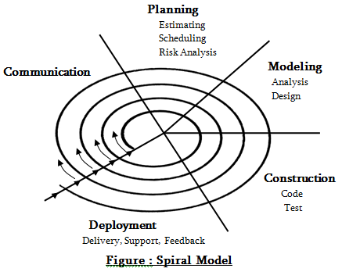

Fig 3.1 – Spiral Model Representation

The Spiral model follows the Iterative Structure. It has many loops and it represents the phases of software development. Each loop may vary depending upon the project risks.

6

**Communication Phase: -**

Before working on the requirements that is before it can be analyzed, modelled, or specified they must be gathered through a communication activity.

The team meets is what actually needed to discuss the idea and to identity each other’s strength to distribute the modules easily.

The communication process makes the other process easier to start with and leads to the correct path of development of a project

It includes: -

• Informal Meetings

• Personal discussions

• Reviewing features

* Admin Functionalities
* User Functionalities
  + - Teacher Functionalities
    - Student Functionalities

**Planning Phase: -**

The planning activity includes the management of overall project development and technical practices that enable the software team to define a road map as it travels toward its strategic goal and tactical objectives.

It includes the issues like: -

• Identification of the reasons for developing the Homework Planner System.

• Identification of the functionalities to be built in

* Security Features
* Admin, Teacher and Student functionalities

• Proper scheduling of the development

* One Week (Approx.) For Developing the System.

7

**Modeling Phase: -**

Modeling is a phase where we got clear idea about what the project would look like and how it will be developed. Under this phase, models are developed to gain a better understanding of the actual entity to be built.

This includes analyzing and understanding the requirement and based on that design the Use Case, Database Diagrams to get the idea of how the system will function.

**Construction Phase: -**

The construction phase of the spiral model includes the coding and testing tasks that leads to operational software that is ready for delivery to the end-user (deployment ready software).

• Coding

* The creation of programs or database using codes and statements in C# and SQL. the tool used is visual studio

• Testing

* After the programs get created, they are tested with the intent of finding any error that was left undetected during the coding phase. The basic testing’s that have been done are: -
* Unit Testing

This is done over the individual units like Teacher module is tested individually likewise for student and admin.

* Integration Testing

All the three modules Admin, Teacher and Student are combined together and the integrated testing is done to check the flaws if any.

**Deployment Phase: -**

This phase encompasses following activities: -

* Delivery of Software, Customer Support and Feedback from the end user
* Based on the feedback received the loop continues with the iterative product development phase until the requirement satisfies.

8

**Chapter 4**

**TOOLS / PLATFORM USED**

**CHAPTER 4: TOOLS / PLATFORM USED**

**4.1 Hardware Details**

**Processor: Intel Core i5 or above**

It is available as dual-core or quad core i5 known as a computer processor invented by Intel, the Core i5 is a computer processor, available as dual-core or quad-core. The Core i5 processor is available in variable speeds, ranging from 1.90 Ghz up to 3.80 Ghz and it features 3 MB, 4 MB or 6 MB of cache. It utilizes either the LGA 1150 socket on a motherboard.

**Hard Disk: 500 GB Hard Disk space. 40 GB Free space on HD.**

A hard disk is a disk drive that stores and provides relatively quick access to huge amounts of data on an electromagnetically charged surfaces. A “head” primarily writes or reads the information on the tracks. Two heads, one on all sides of a disk, read or write the info because the disk spins. A hard disk or drive unit comes with a group rotation speed varying from 4500 to 7200, the physical location is often identified with the cylinder, track, and sector locations, and these are actually mapped to a Logical Block Address of the hard disk.

**Random Access Memory: 8 GB**

When we talk about computer memory, they usually it means the volatile Random-Access Memory. This RAM memory consists of some integrated circuit Chips (IC chips) either on the motherboard or on a small circuit board attached to the motherboard. If the computer performance is very poor that’s why computer’s motherboard is designed in a manner that its memory capacity can be enhanced by adding more memory chips. Hence, if you decide to have more memory than your computer currently has then there is an option of multithreading, you can buy more memory chips, and plug them in the empty memory slots on the motherboard. This job is normally done by the service engineers who manages everything.

                      9

**4.2 Software Details**

**FRONT END - Visual Studio 2019 & C#**

Microsoft invented an IDE and that is Visual Studio. It is used to develop computer programs, also as websites, web apps, web services and mobile apps. We can implement Web API, Windows Forms, Windows Presentation Foundation, Windows Store and Microsoft Silverlight in visual studio.  
C# could also be a strongly-typed object oriented programing language designed to offer the optimum blend to simplicity, expressiveness, and performance.

**Visual Studio 2019:**

The tool used to perform .NET framework application using the Visual Studio with the version 2019. It allows creating website applications, console applications. We can perform Testing as well. It allows various packages to be installed using NuGet Package Manager. It supports assemblies and class Libraries. Visual Studio is downloaded with various such functionalities from another tool called as Visual Community.

**.NET Framework:**

The .NET Platform is used to develop enterprise applications based on industry standards. The .NET platform is a more powerful, more flexible, and simpler programming model than COM. NET Framework. It is mainly divided in two features.

Console Application – To create console related CSHARP related programs.

Web Application – To create websites

Templates used while creating .NET Framework Web Applications:

Ø  **.Net Framework – Asp.NET Web Application (web API):**

It is a template that helps creating Web API application Services. It is a kind of interface over web. When developer wants to deal with Request and Response kind of Project based on HTTP Protocol then Web API is used.

When user sends requests, it is sent via HTTP protocol the server then checks for the response if it gets it then the server returns it back to the client.

10

**.NET Framework – Asp.NET Web Application (MVC)**

This template helps in creating Model View Controller application. This architecture is helpful when the user interacts with UI over website submits some data then it moves towards the controller which finds the routes from there it finds models to make necessary changes into the Data Model.

In MVC we can choose the security options like Windows Authentication, Individual User Account Authentication.

**Entity Framework 6–**

It helps in accessing data without writing the code. EF enables developer to work with relational data as a domain specific object. It is used for Ado.NET to make the connection with the database. There are three approaches mainly:

**1.     Database First Approach:**

a.      In this approach the existing database is used and then the Models are designed.

b.     It is not efficient as if we want to change anything then changes are to be made in the database and that can be risky.

**2.     Code First Approach**

a.      We have used Code First Approach in our project as in this approach the codes are written first and the database is created so designing models are completely avoided.

b.     This is an efficient way as we can efficiently make changes to our code rather than disturbing the database.

**3.     Model First Approach**

a.      In this approach the Entities, Relationships are designed first from EDMX and from there the database is created.

b.     So, for any sudden change the entire relationship has to be changed.

11

**What is NuGet?**

NuGet is the package manager for the Microsoft development platform including .NET which helps developer install necessary packages in visual studio on their own local system. The NuGet client tools gives developers the ability to produce and consume various packages. The NuGet Gallery is the central package repository which can be used by all package authors and consumers as well.

**NuGet Package Manager:** NuGet Package Manager provides a dialog using which we search for a specific package and perform installation or uninstallation of packager.

Example: Entity Framework is downloaded from here.

**NuGet Package Manager Console:** It is command line tool to add and remove package to a project. It uses power shell command for accomplishing this task.

**Packages Required:**

* MySQL Connector(To establish Database Connection), jQuery Validation(To apply Customize Validations and Events), Asp.NET Razor(To implement the View Engine), Microsoft.Asp.NET Web Optimization (To optimize Web Application), Bootstrap (For making Responsive), JSON (to convert data into JSON Format),
* Microsoft.Aspnet.Identity.Entityframework

This package is well known for the Entity Framework (all versions) implementation of ASP.NET Identity which will persist the ASP.NET Identity data and schema to SQL Server.

* Microsoft.Aspnet.Identity.Core

This package includes the core interfaces for ASP.NET Identity. This package is mainly used to write an implementation for ASP.NET Identity which targets the different persistence stores such as Azure Table Storage, nosql databases etc.

* Microsoft.Aspnet.Identity.OWIN

This package contains functionality that is used to plug in OWIN authentication with ASP.NET Identity in ASP.NET applications that is basically for performing authentication of user. This is used when you add log in (user is not authenticated) functionality to your application and call into OWIN.

Cookie Authentication middleware to generate a cookie.

* Unit Testing Framework:

It is unit-testing framework for all .NET languages and it helps in performs Unit Testing over the Project modules. It is downloaded from NuGet Package Manager. It shows whether the test cases are successful or failed.

12

* Postman

It is a platform for API Development that means whenever the request is made from the client it sends back the response from the server and this process is handled using REST API.

* Swagger

It describes the RESTful API. It includes automated documentation, code generation and test cases generation.

* Alertify

It is a front-end package that is used to show the notifications or alerts to the user that enhances the User Interaction. It can be downloaded from the NuGet Package Manager.

**BACK END : - Microsoft SQL Server 2014**

Microsoft SQL Server is one of the relational model database server produced by MICROSOFT. Its main query languages are Transact-SQL and ANSI SQL. SQL Server allows multiple clients to use the same database concurrently that increases the efficiency.

As such, it needs to control concurrent access to shared data, to ensure integrity- when multiple clients update the same data, or clients attempt to read that is in the process of being changed by another client.

13

**Chapter 5**

**DESIGN AND IMPLEMENTATION**

**CHAPTER 5: DESIGN AND IMPLEMENTATION**

**5.1 ARCHITECTURE**

**ARCHITECTURE FOLLOWED IN SPRINT 1:**

* Layered Architecture
  + It is a client-server architecture in which the functional processes of user interface, business logic and data access layer are developed and maintained as independent modules on separate platforms. The layer architecture is a software design pattern and well-established software architecture.
  + The architecture is bidirectional if user is submitting the data then it goes from Presentation Layer – Business Layer – Data Access Layer but if user wants to fetch the data then it goes like from Data Access Layer – Business Layer – Presentation Layer
  + This layers include:
    - Presentation Layer
    - Business Layer
    - Data Access Layer
    - Exception Layer
    - Entities Layer
* **Advantages**
* Reusability: Moving code-behind libraries. It is possible to make modifications in the presentation Layer without effecting the other two Layers (business Layer or data access layer).
* UI (Presentation Layer), Business logic and Data Access Layer are decoupled.
* Maintainability: When we change one layer due to the client's needs in between the development is going on or when the development is completed then the changes doesn't affect the other layers and we need to do less changes in another layers.
* If the project is need to be moved from Windows application to a website application then only the UI is changed otherwise all the other layers remain the same and continues with same approach depending on your business needs the database changes. Only the Data Access Layer is changed and the rest of the things are remained unaffected.

14

**ARCHITECTURE FOLLOWED IN SPRINT 2:**

* **MVC (Model View Controller)**
  + The **Model-View-Controller (MVC)** is an architectural pattern that separates an application into three main logical components: the **model**, the view, and the controller. Each of these components are built to handle every aspects of application development. MVC is the best architecture to follow for the website developers and is most frequently used industry-standard web development framework to create scalable and extensible projects.
* **MVC Components**

Following are the components of MVC –

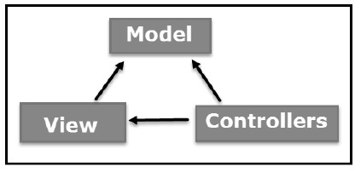

Fig 5.1 – MVC DIAGRAM

* + - **Model**

The Model component of the MVC architecture corresponds to all or any the data-related logic that the user works with. This represent either the data that's being transferred between the View and Controller components or the opposite business logic or application logic-related data. For instance, an educator object will retrieve the Teacher’s Personal information from the database, modify, manipulate it and update it data back to the database or use it to render data.

* + - **View**

The View component of the MVC architecture is used for all the UI logic of the application that user can interact with. For instance, the Teacher’s view includes all the UI components like boxes, dropdowns, etc. That the ultimate user (Teacher, Admin) interacts with.

15

* + - **Controller**

Controllers act as a middleware between Model and View components to process all the business logic and incoming requests, manipulate data using the Model component and interact with the Views to render the ultimate output. For instance, the Teacher controller will handle all the interactions and inputs from the Teacher’s Profile View and update the database using the Teacher Model. The Equivalent controller will be used to view the Teacher’s data by accessing the Models having database connected with it.

**Advantages-**

* + - Ideal for developing complex but lightweight applications.
    - Provides an extensible and pluggable framework, which may be easily replaced and customized. For example, there are two different types if views available to render the UI, if you do not wish to use the in-built Views like Razor or ASPX View Engine, then you can use other third-party view engines or we can even customize the existing ones.
    - It utilizes the component-based design of the application by logically dividing it into three components Model, View, and Controller components. This enables the developers to manage the complexity of large-scale projects and work on individual components that is if multiple team members are working on one project separately while integrating all together there would not be any problems regarding the code integration.
    - ASP.NET MVC Framework is ideal for projects with large team of web developers and also for the large projects.
    - It supports Authorization and Authentication, Master Pages, Templates, Data Binding, User Controls, Memberships, ASP.NET Routing, etc.
    - It does not use View State Concept. This approach is very beneficial and helps in building applications, which are lightweight and easy to use, also it gives full control to the developers.

16

**5.2 IMPLEMENTATION**

**USER CASE DIAGRAM:**

The above use case diagram denotes the roles of User. There are three users:

* Admin: add, search student, teacher, and course and has all the rights of teacher.
* Student: Login, Enroll Course, Plan Homework, View assigned Homework, and Search Course
* Teacher: Login, teach course, view assigned homework, schedule homework, get course overview, get student overview.

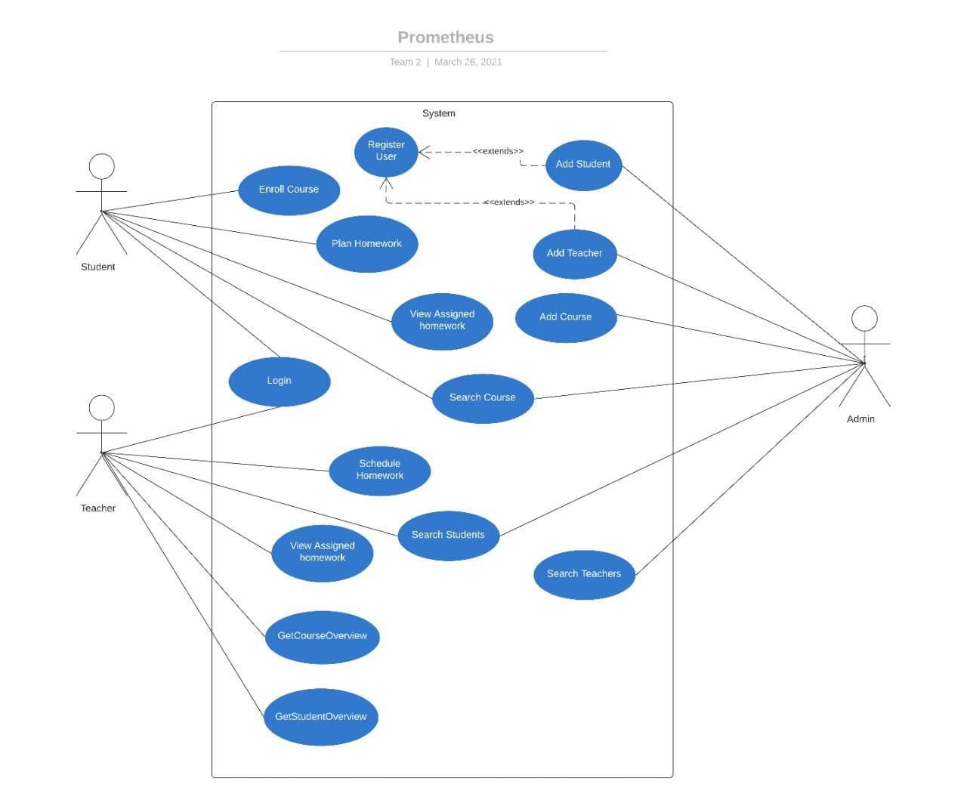

Fig 5.2 – User Case Diagram Of Prometheus

17

**DATABASE DIAGRAM:**

Database Diagram shows the structure of the database with primary keys and its relationships between each other.

Example. For one Homework there will be one Homework Plan only so that indicates 1-1 relationship and for one course there can be multiple homework’s hence it indicates 1-many relationship etc.

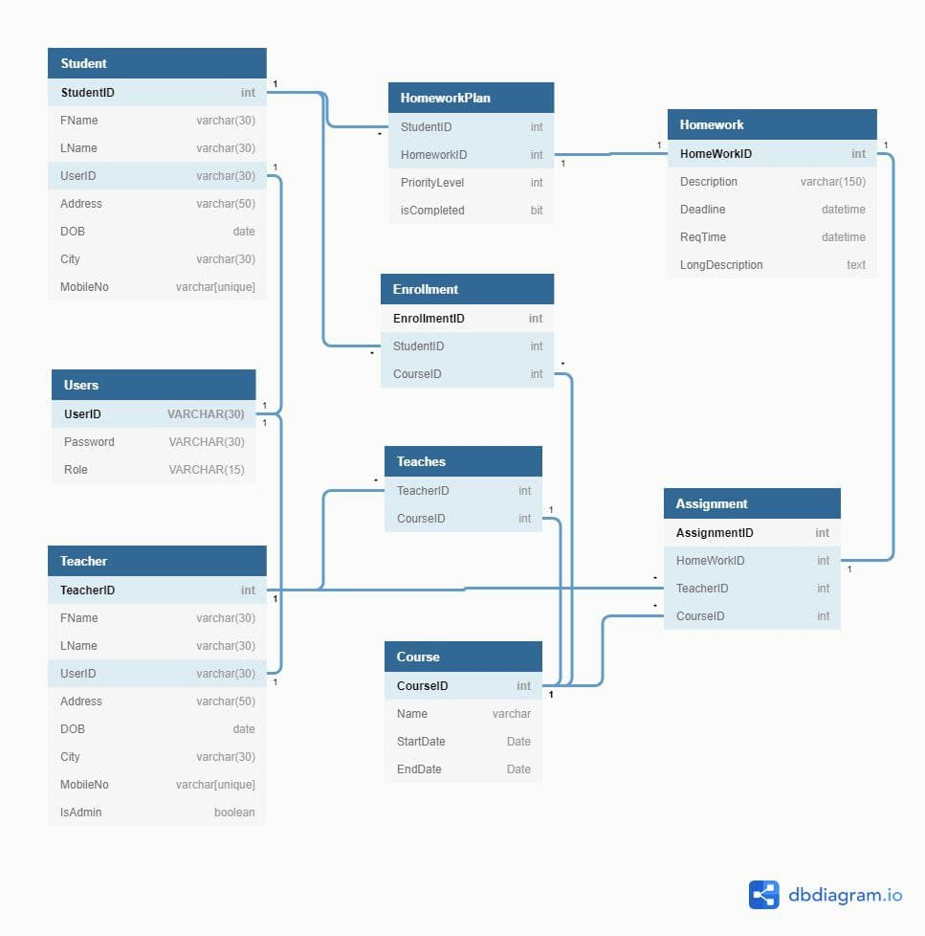

Fig 5.3 – Database Diagram Of Prometheus.

18

**Database Tables-**

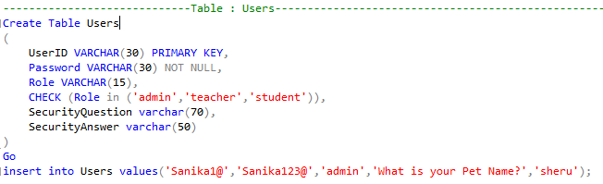

Fig. 5.3.1 Users Table

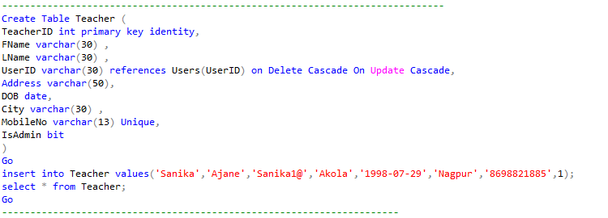

Fig 5.3.2 Teachers Table

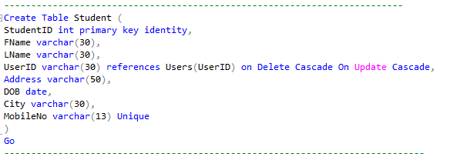

Fig 5.3.3 Students Table

19

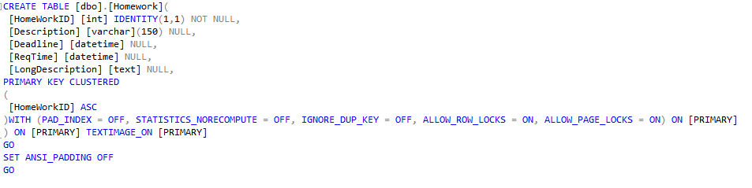

Fig 5.3.4 Homework Table

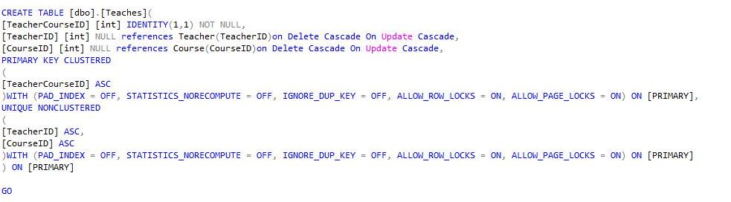

Fig 5.3.5 Teaches Table

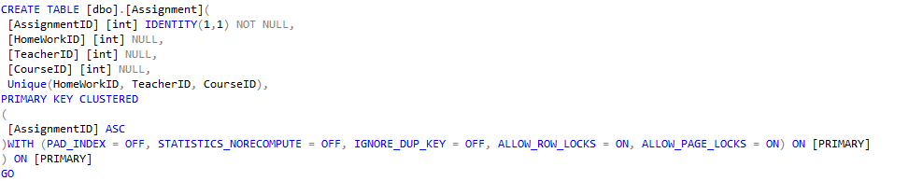

Fig 5.3.6 Assignment Table

20

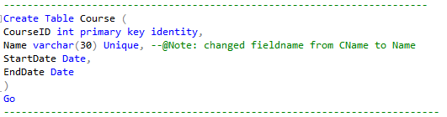

Fig 5.3.7 Courses Table

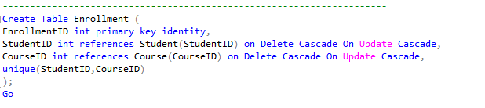

Fig 5.3.8 Enrollment Table

21

**SPRINT 1 PROJECT SNAPSHOTS ( DESKTOP APPLICATION)**

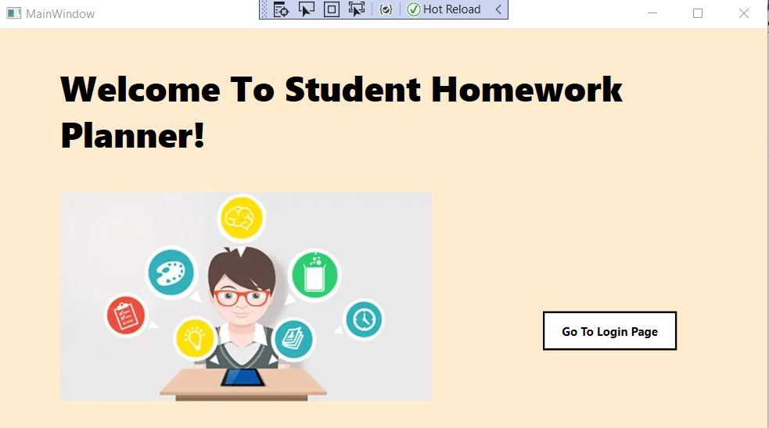

Fig.5.4: This is Main Screen of our desktop application Prometheus. For login into respective account, click on ‘ Go to Login Page’ button.

22

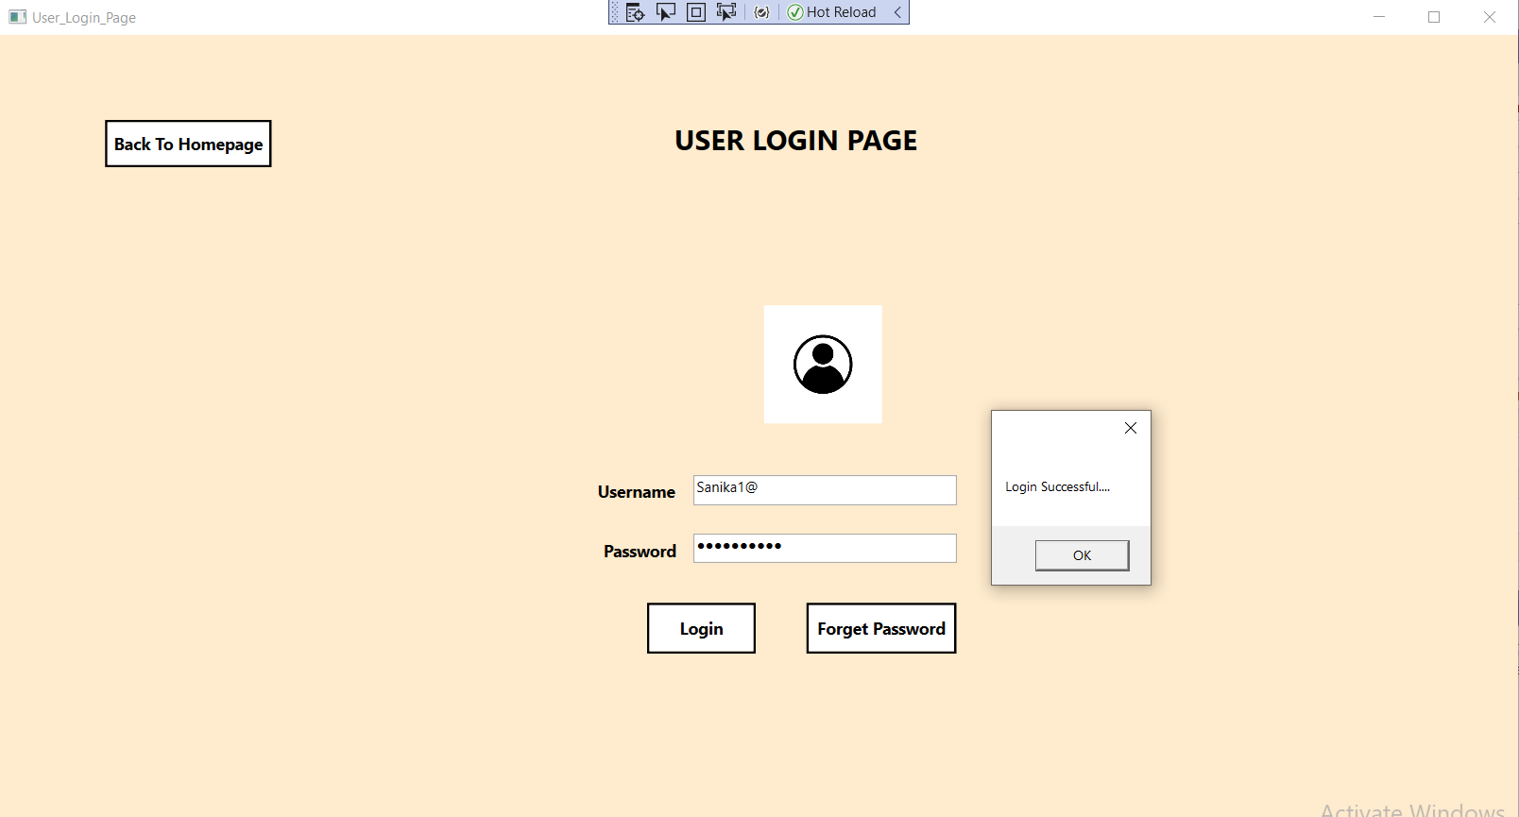

Fig.5.5: This is User Login page of our Desktop application. We have a common Login page for Admin , Teacher & Students. Based on role , the respective screen will be displayed on successful authentication.

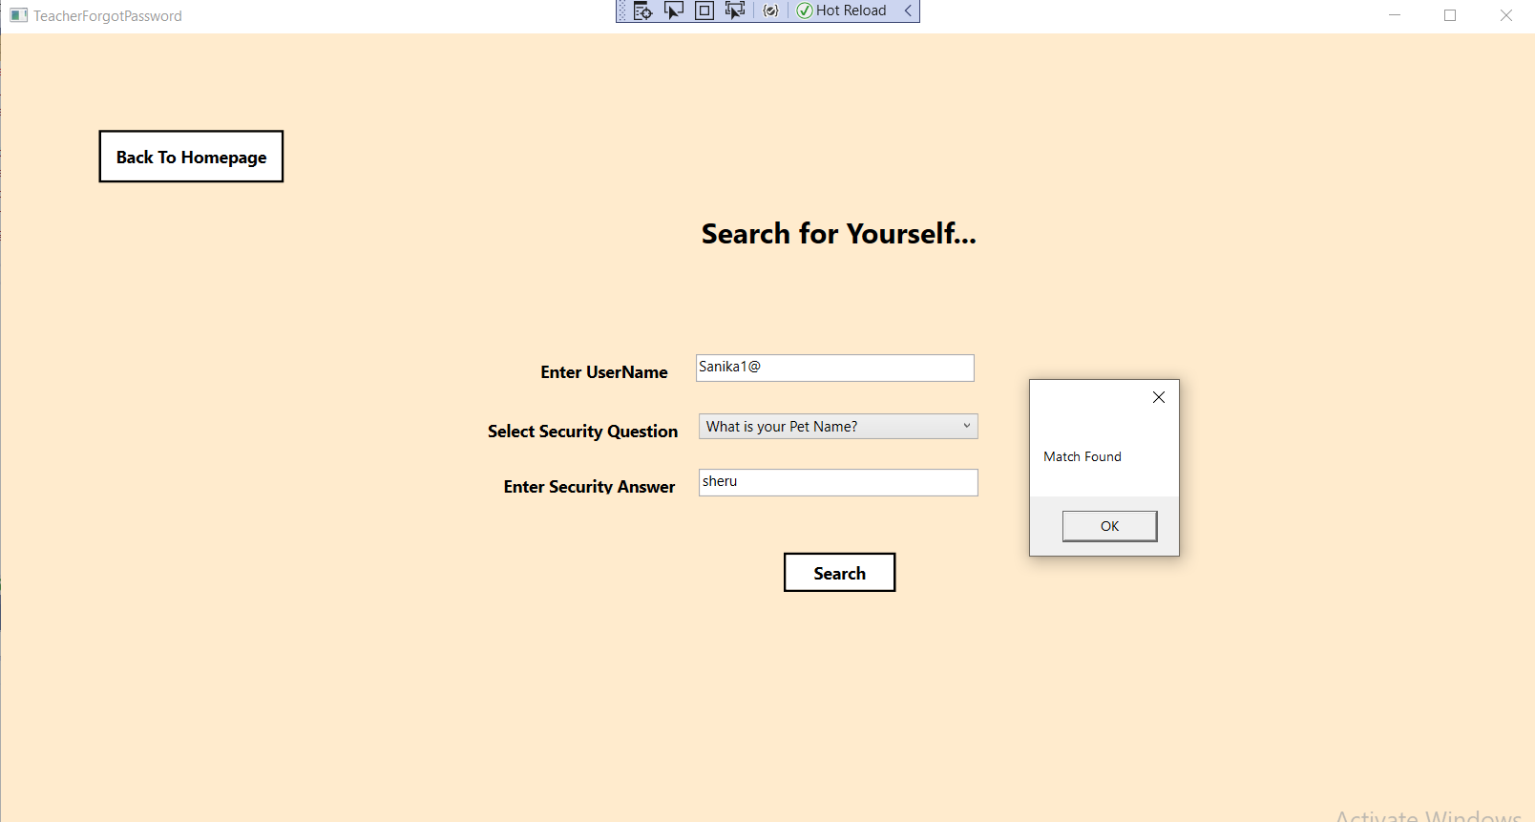

Fig.5.6: Incase, User forgot his password he can set-up a new password. He has to enter his username and needs to correctly answer to the security question which should match with the answer which he gave during registration process.

23

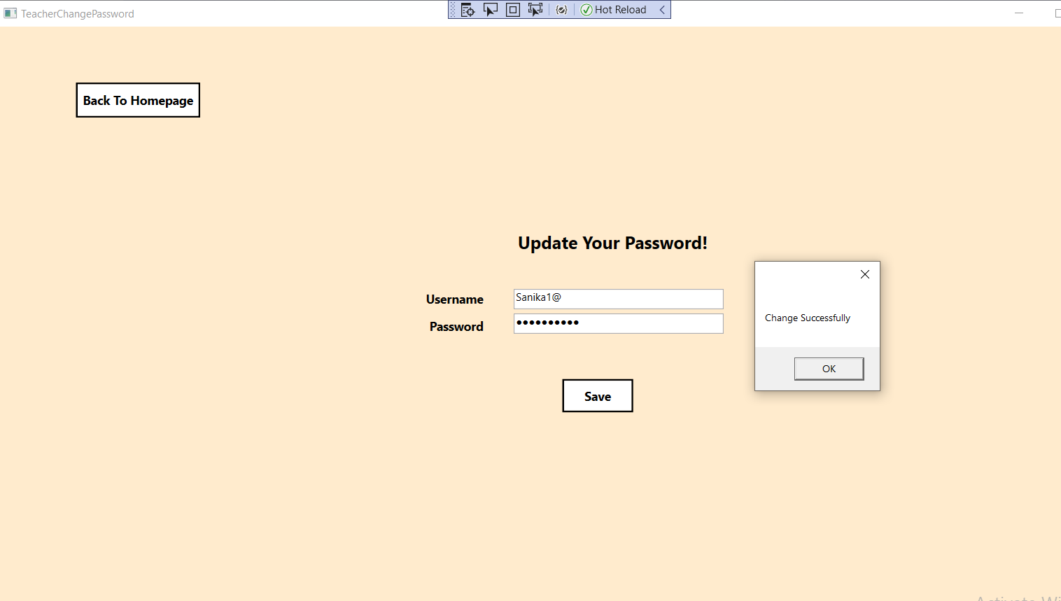

Fig.5.7: User can update his password.

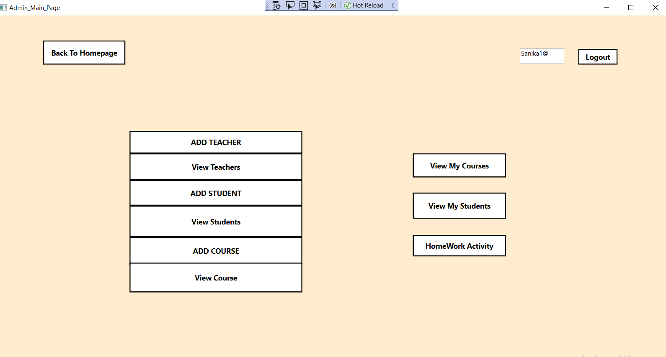

Fig.5.8: This is Main Screen of Admin Profile. Admin is also a Teacher. So along with Admin Functions , Teacher Functions will also be displayed on screen.

Admin can perform tasks like –

1) Adding Teachers in the application.

2) Can View all the teachers added in the application.

3) Adding Students in the application.

4) Can view all the students added in the application.

5) Adding Course in the application.

6) Can view all the courses added in the application

24

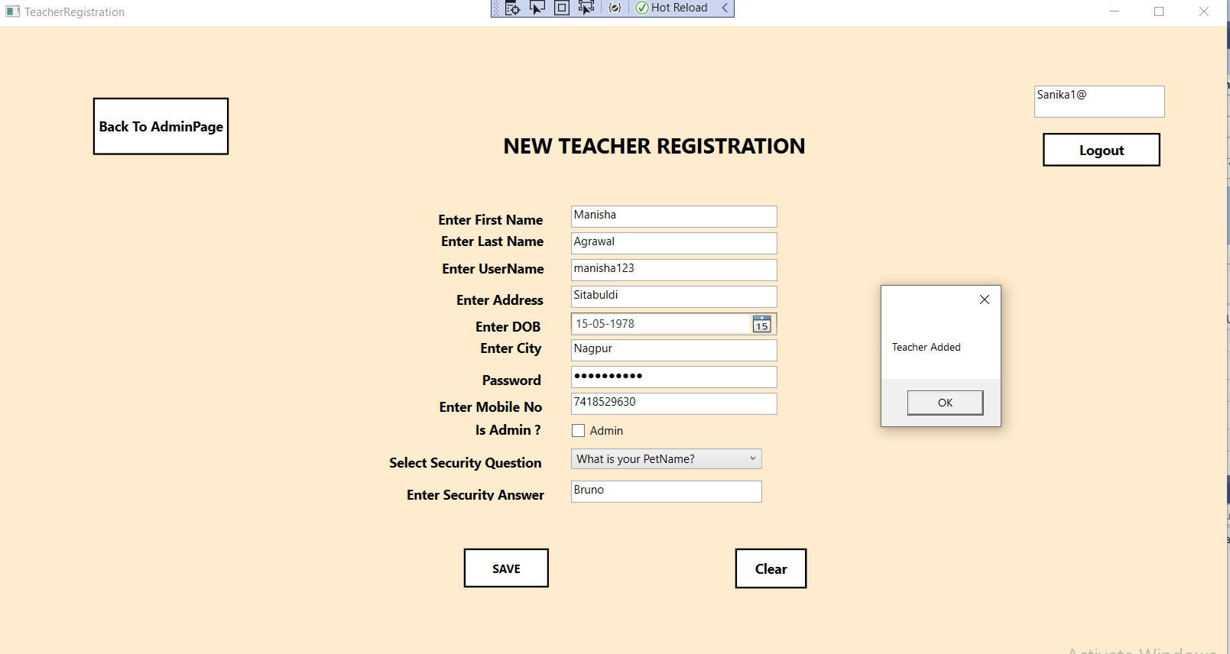

Fig.5.9: This is Teacher Registration Page. For Teacher to be able to use application, Admin has to add teacher in the application. The Teacher has to fill the registration form with all details and then admin will add teacher into the system.

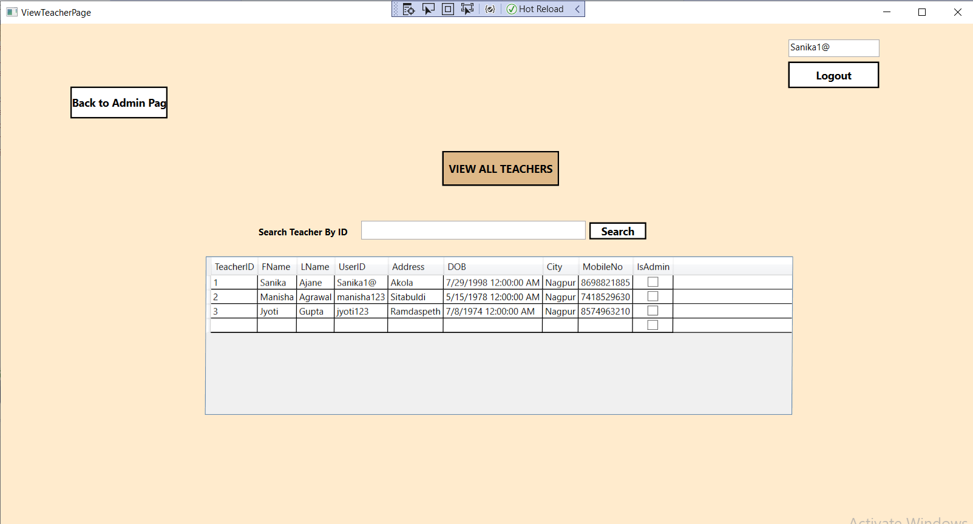

Fig.5.10: Admin can view list of all the teachers added into the application.

25

Fig.5.11:Admin can also view particular Teacher by User ID.

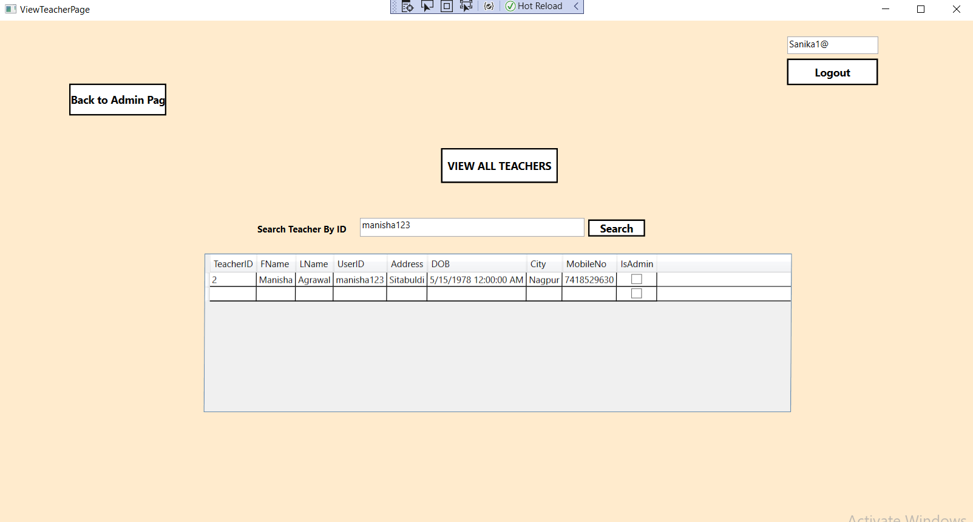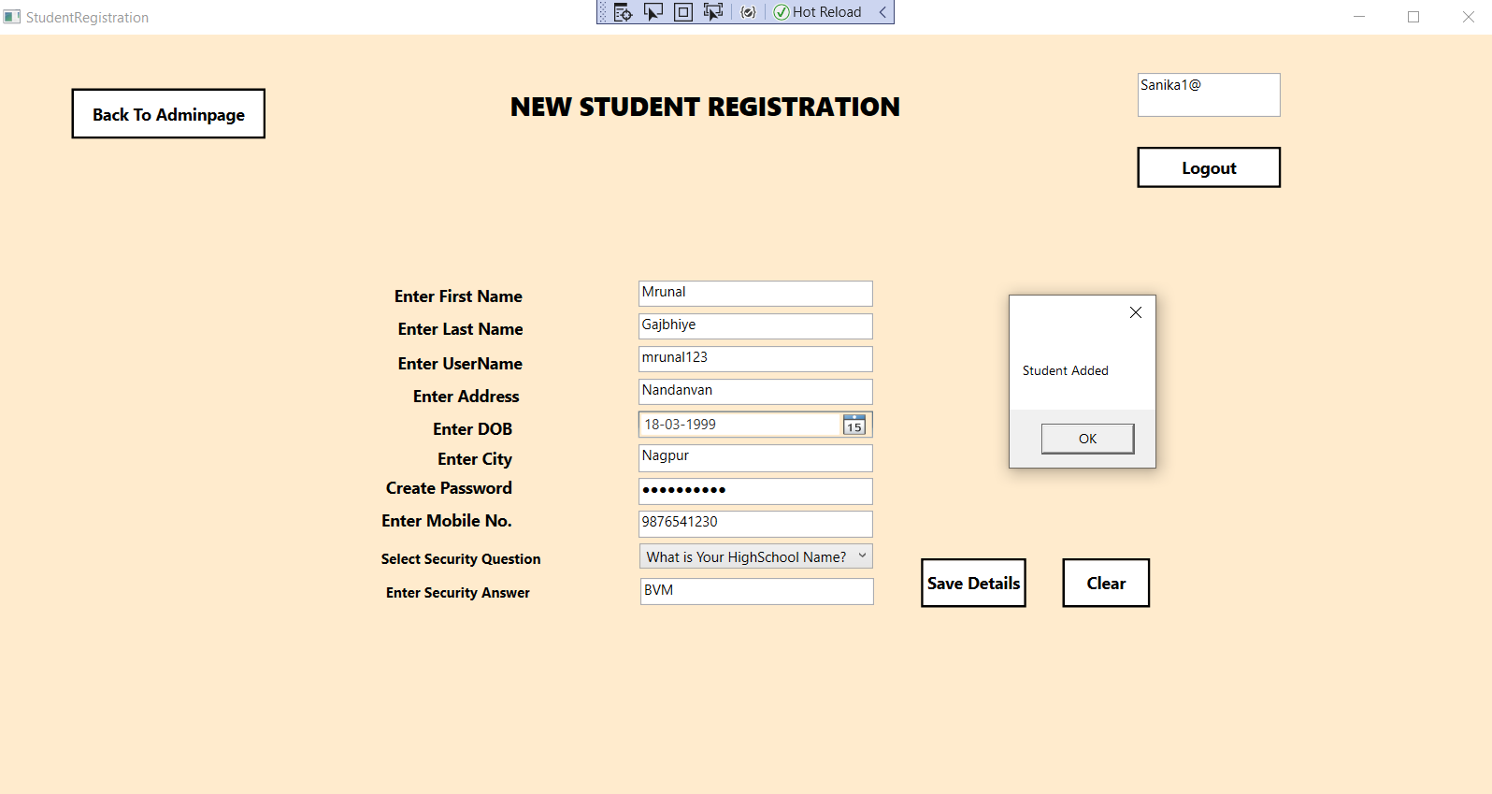

Fig.5.12: This is Student Registration Page. For Students to be able to use application, Admin has to add Students in the application. The Students have to fill the registration form with all details and then admin will add students into the system.

26

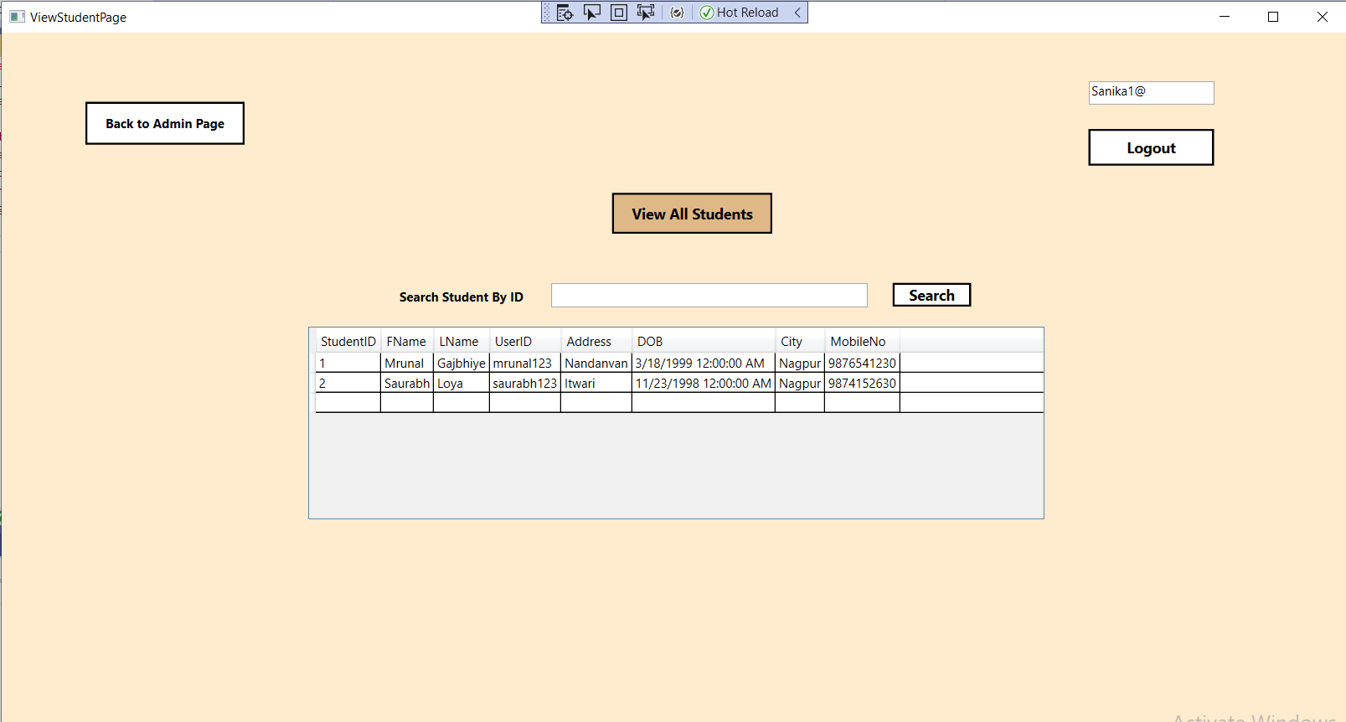

Fig.5.13: Admin can view all the students that have been added into the application.

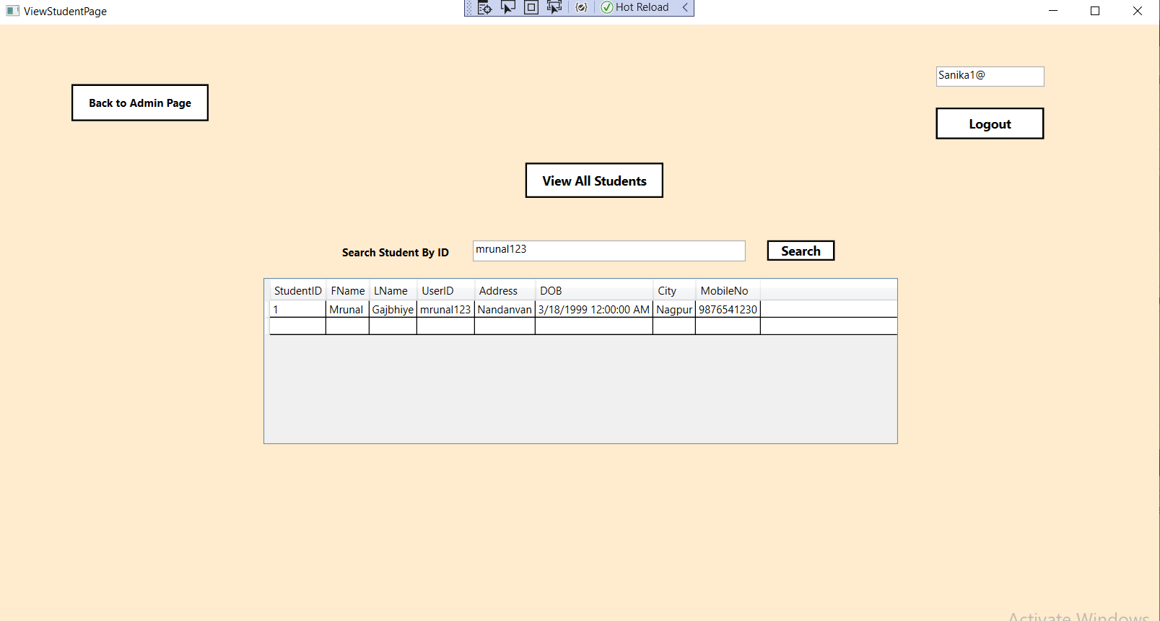

Fig.5.14: Admin can also view particular student by his UserID.

Fig.12: Only admin has the authorization to add the courses into the application. The Course Name along with its Start and End date has to be mentioned for successfully.

27

adding the course into the application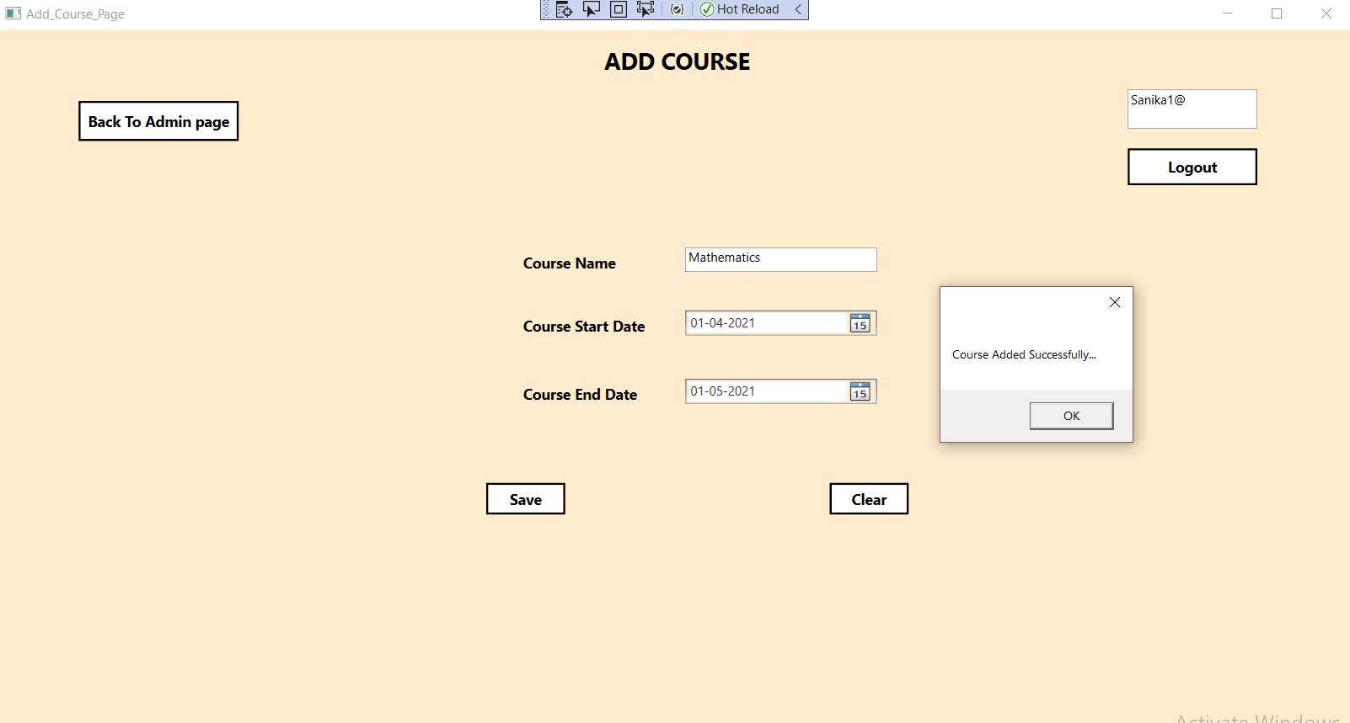

Fig.5.15: Only admin has the authorization to add the courses into the application. The Course Name along with its Start and End date has to be mentioned for successfully adding the course into the application

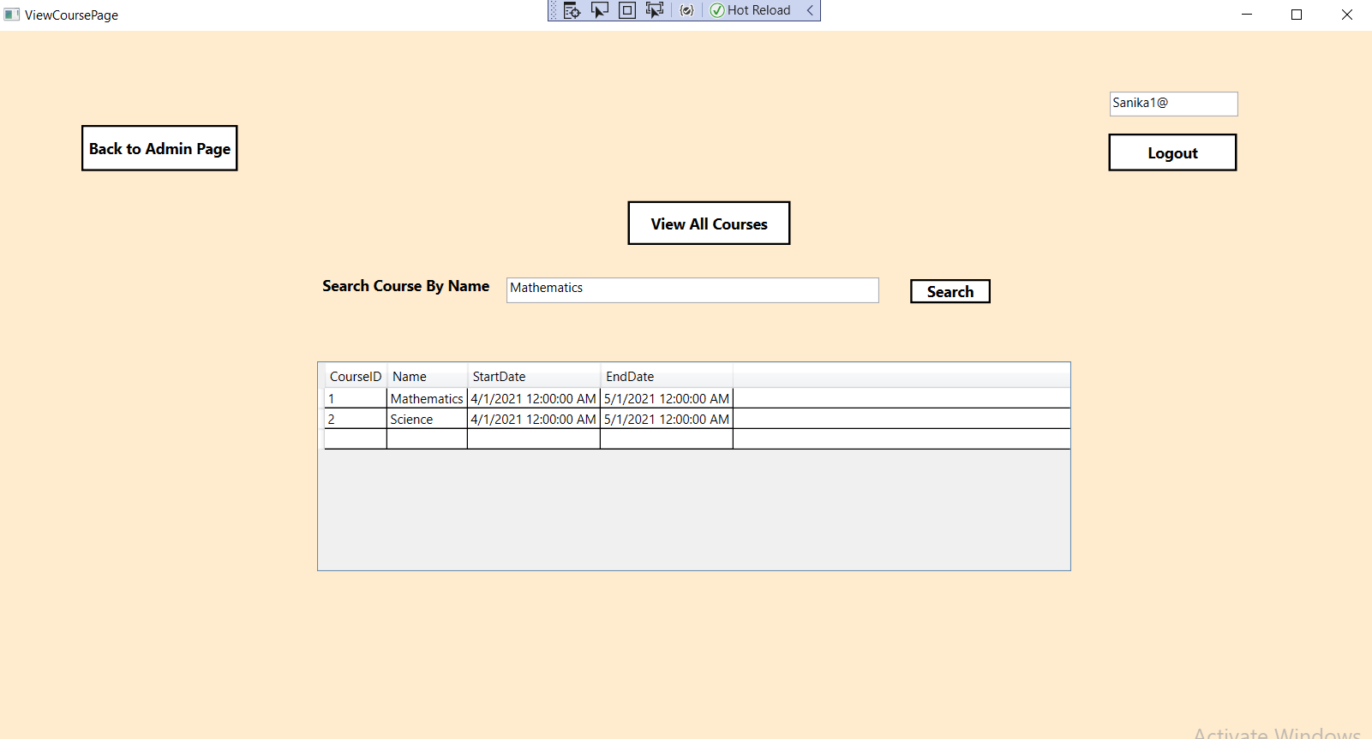

Fig.5.16: Admin can view all the courses that are added in the system.

28

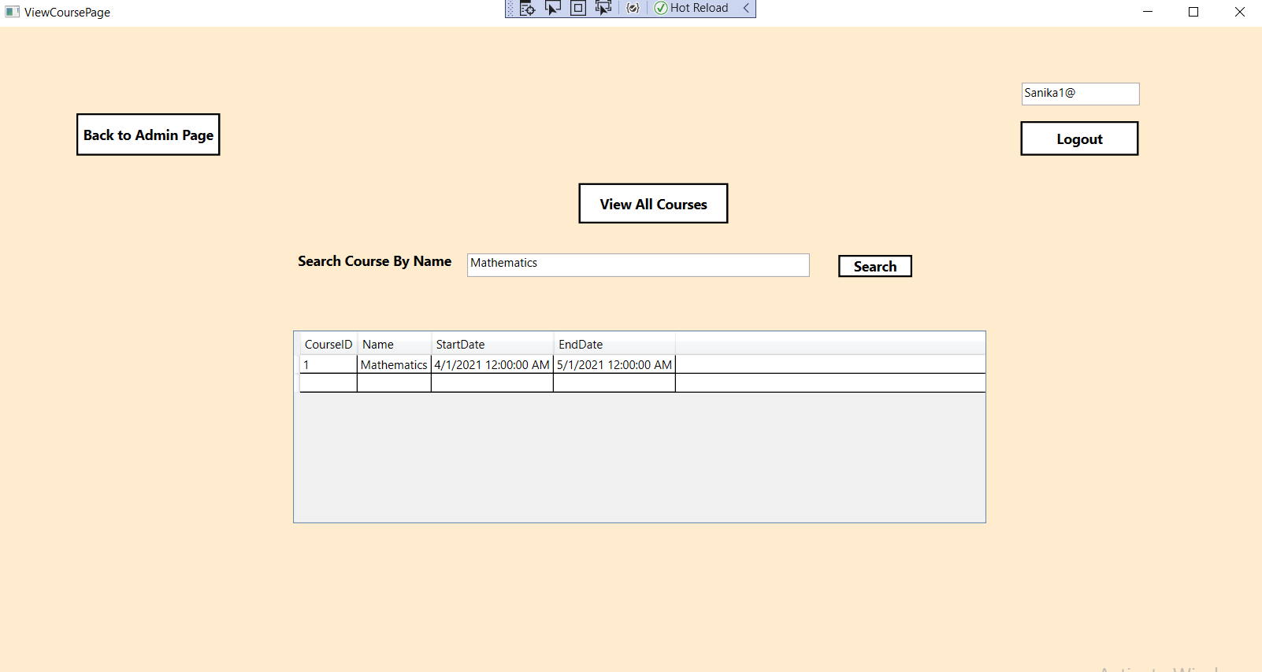

Fig.5.17: Admin can search for a particular course by the course name.

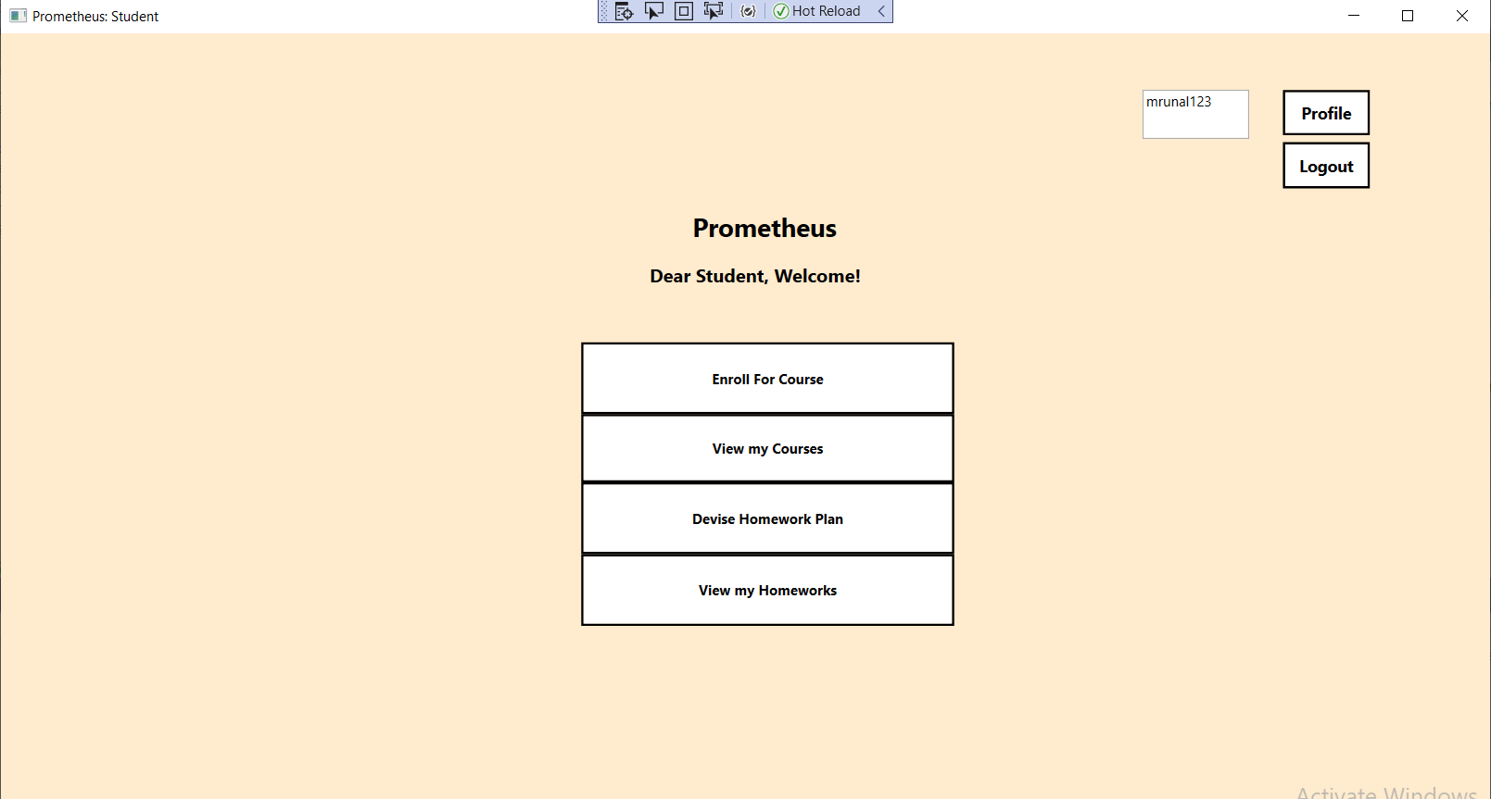

Fig.5.18: This is Student Main screen of our Application. Students can Update their Profile , Enroll for a courses , can view courses they are enrolled in , they Can view the homework’s given and also devise a homework plan.

29

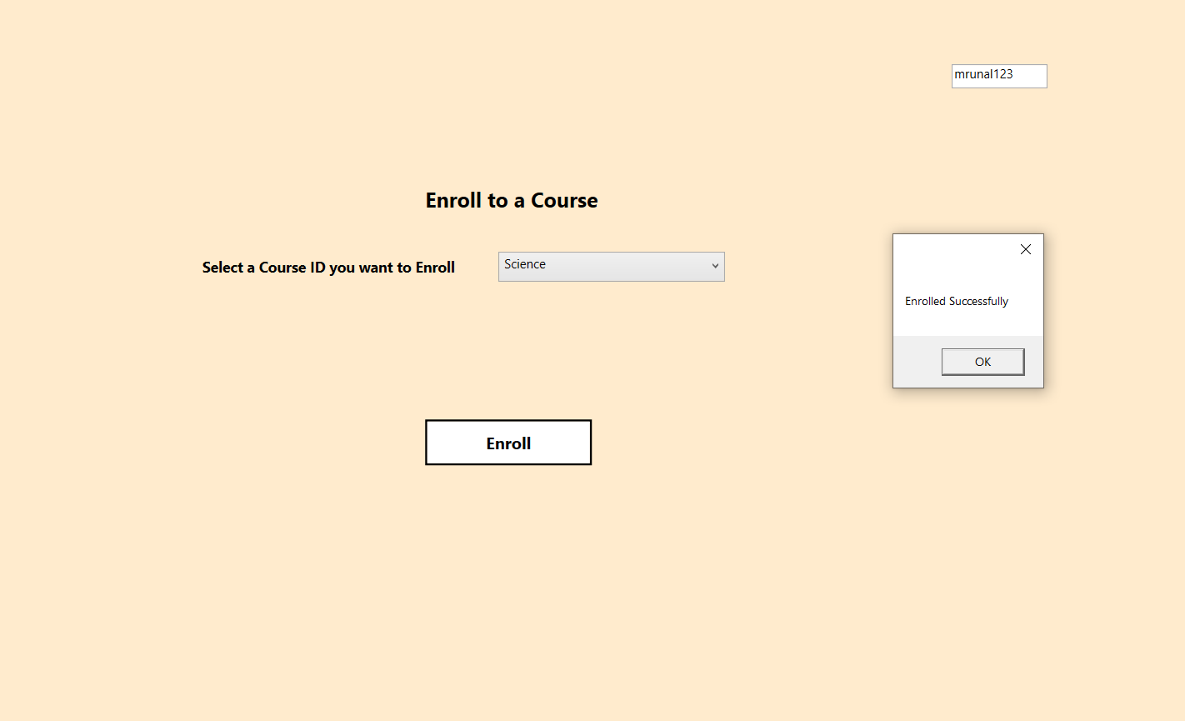

Fig.5.19: Student can enroll for courses.

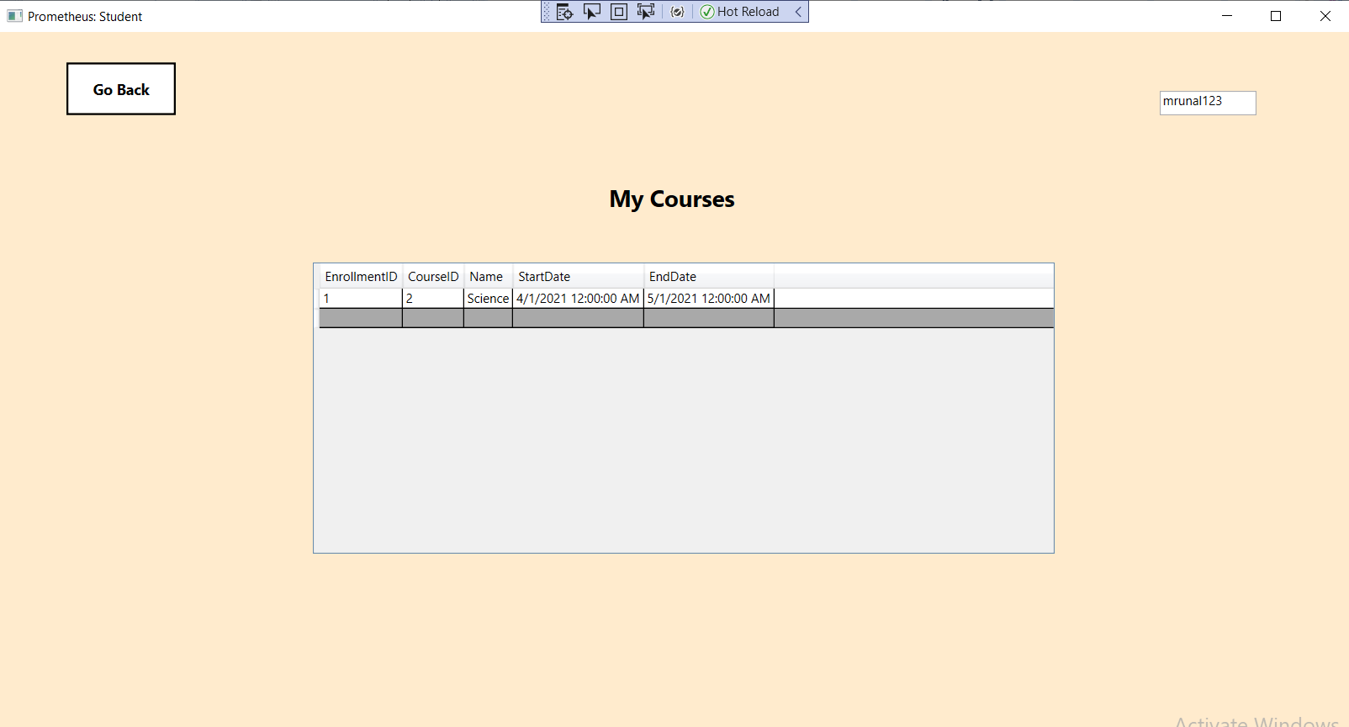

Fig.5.20: Student can view the courses in which they have enrolled.

30

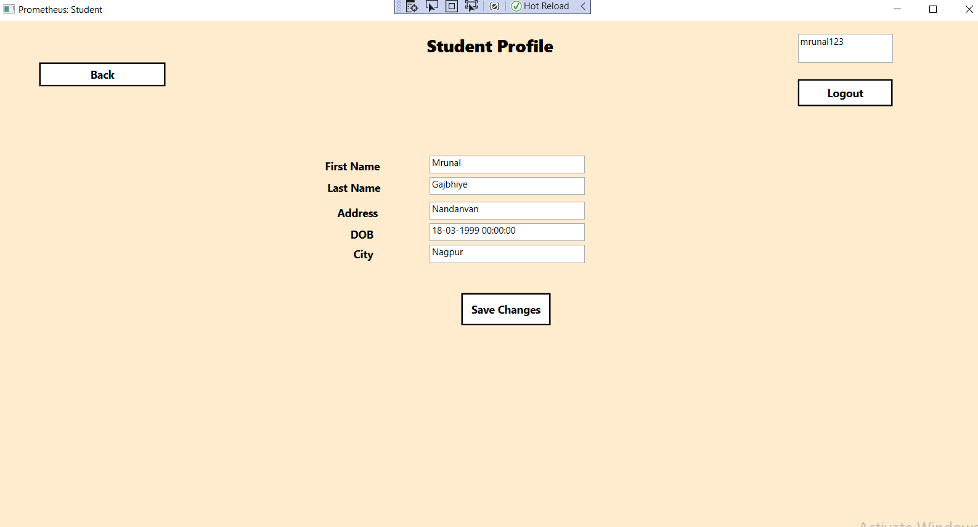

Fig.5.21 : Student can update their profile in case of any changes.

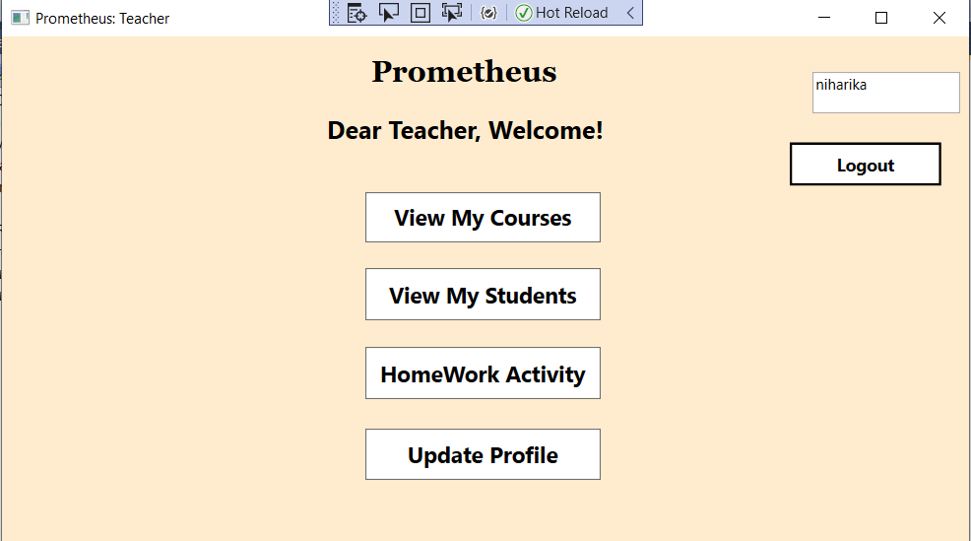

Fig.5.22 : Teacher Main Page

31

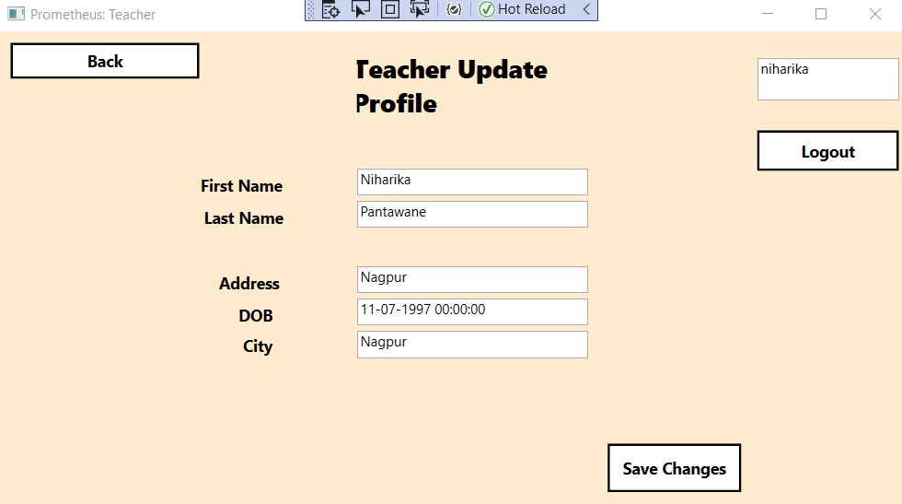

Fig.5.23 :Teacher Update Profile

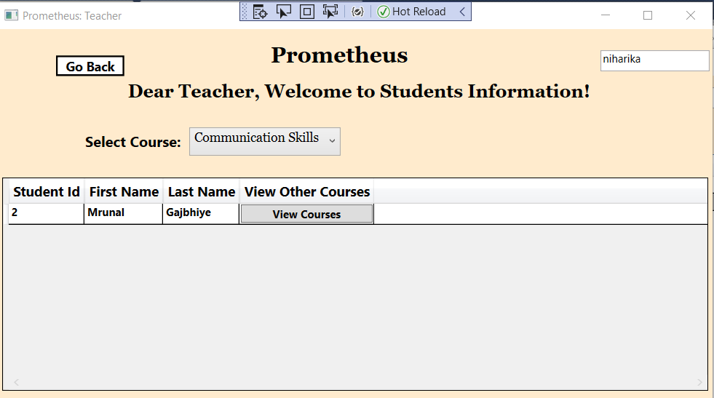

Fig.5.24 : Teacher can view students enrolled for a particular course.

32

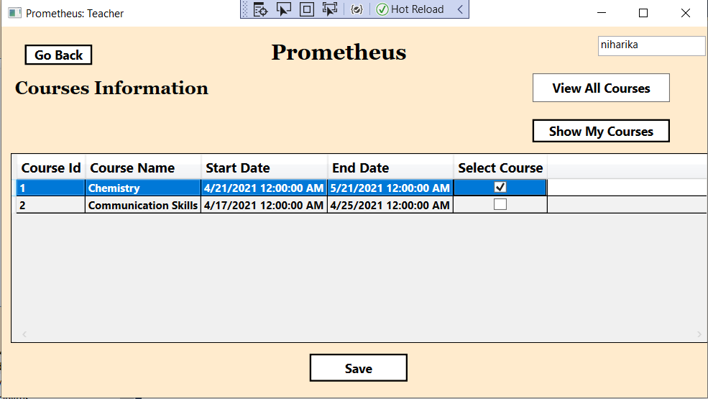

Fig.5.25 : Teachers can view all courses available for the teachers to teach and save the course as My courses to teach

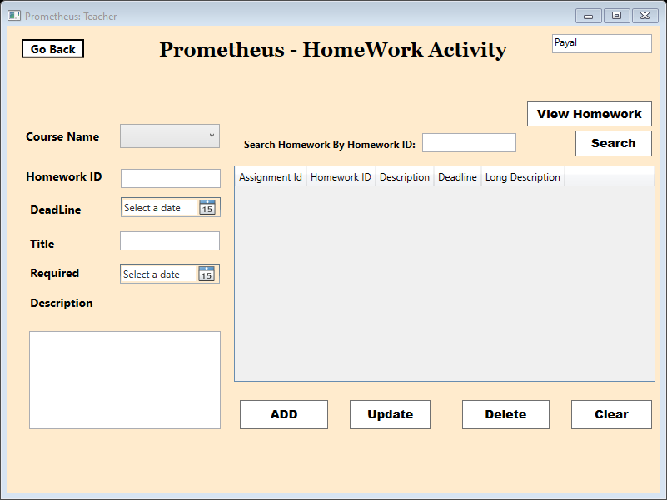

Fig.5.26 : Homework Scheduling

33

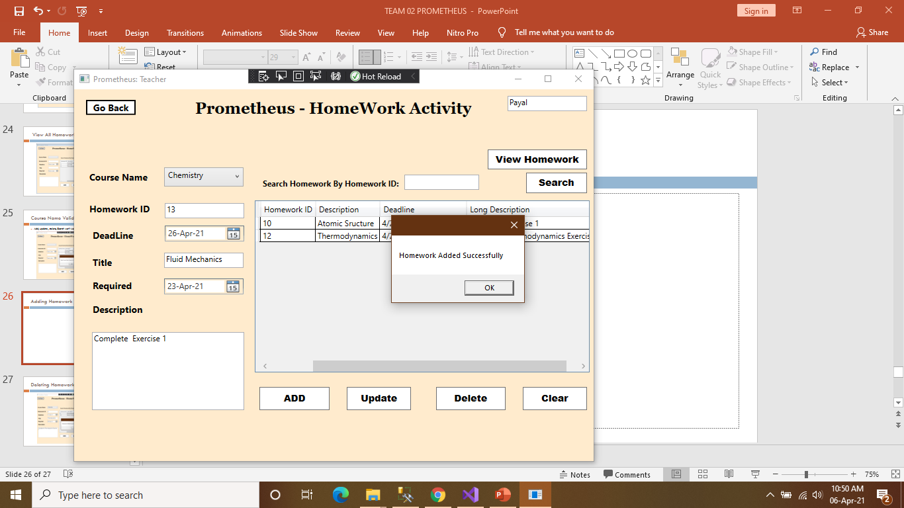

Fig.5.27 : Homework Added

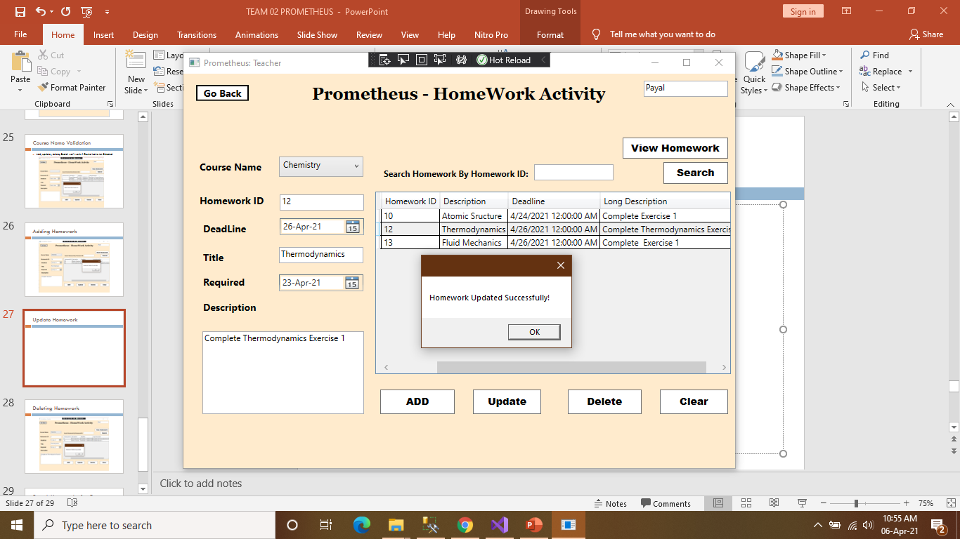

Fig.5.28: Homework Updated Successfully

34

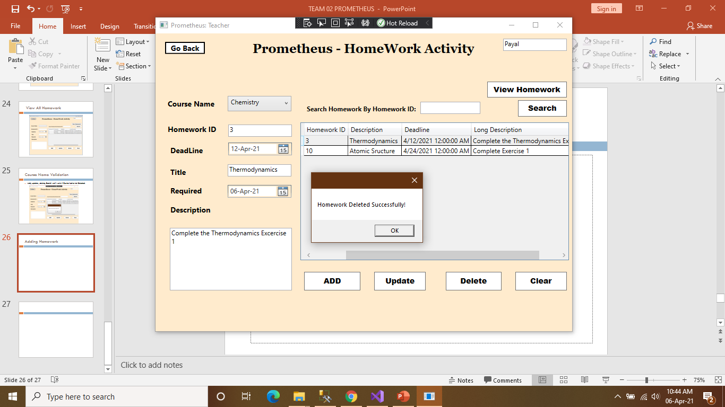

Fig.5.29: Homework Deleted

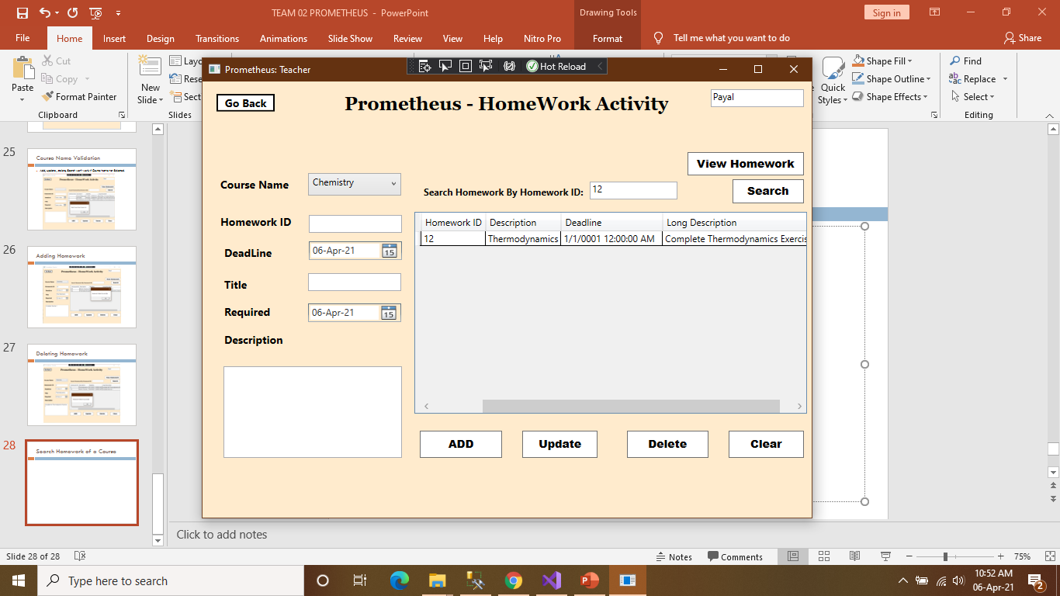

Fig5.30 : View Homework and search Homework

35

**SPRINT 2 PROJECT SNAPSHOTS (WEB APPLICATION):**

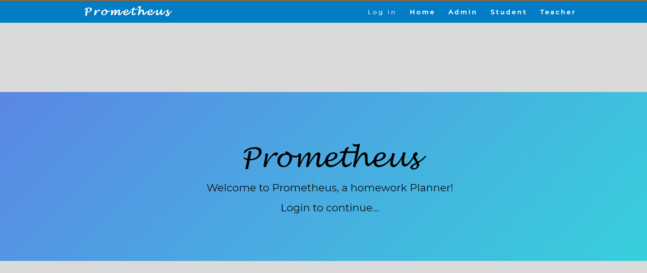

Fig.5.31: This is Main Screen of our web application Prometheus.

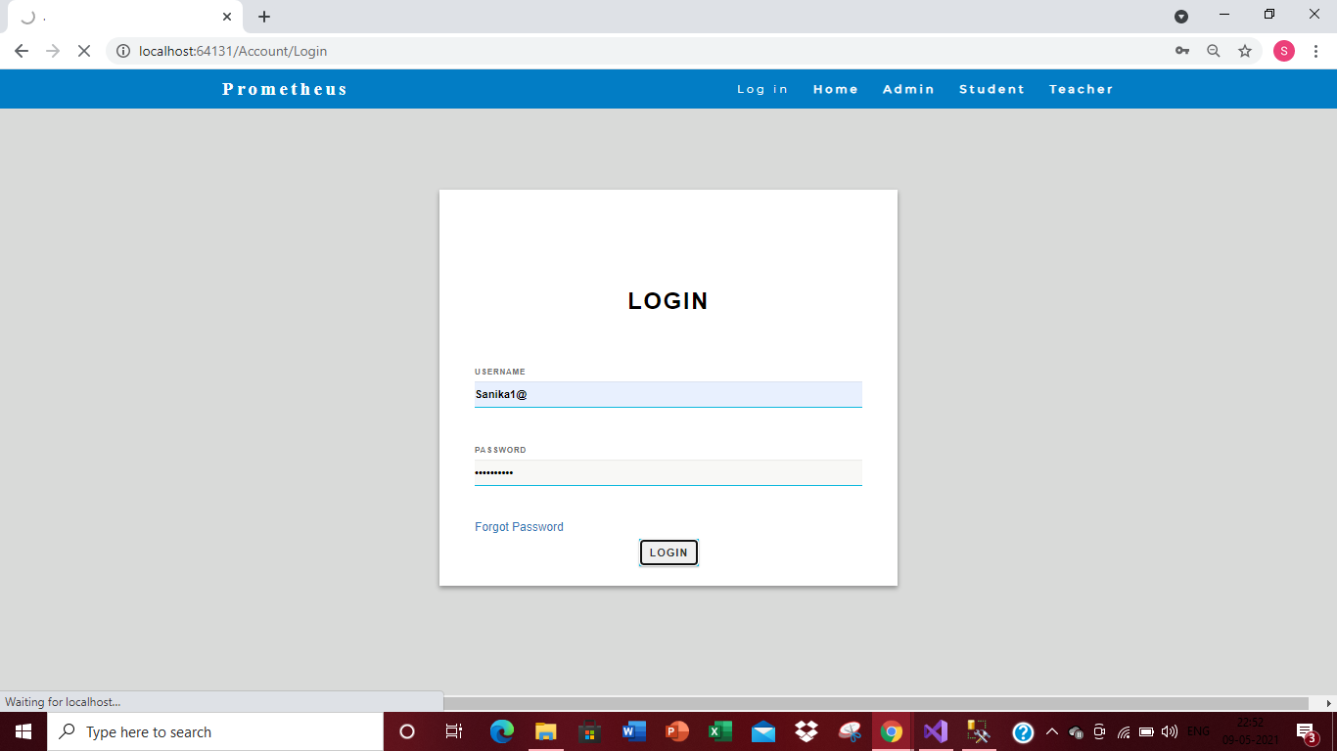

Fig. 5.32: This is User Login page of our Web application.

36

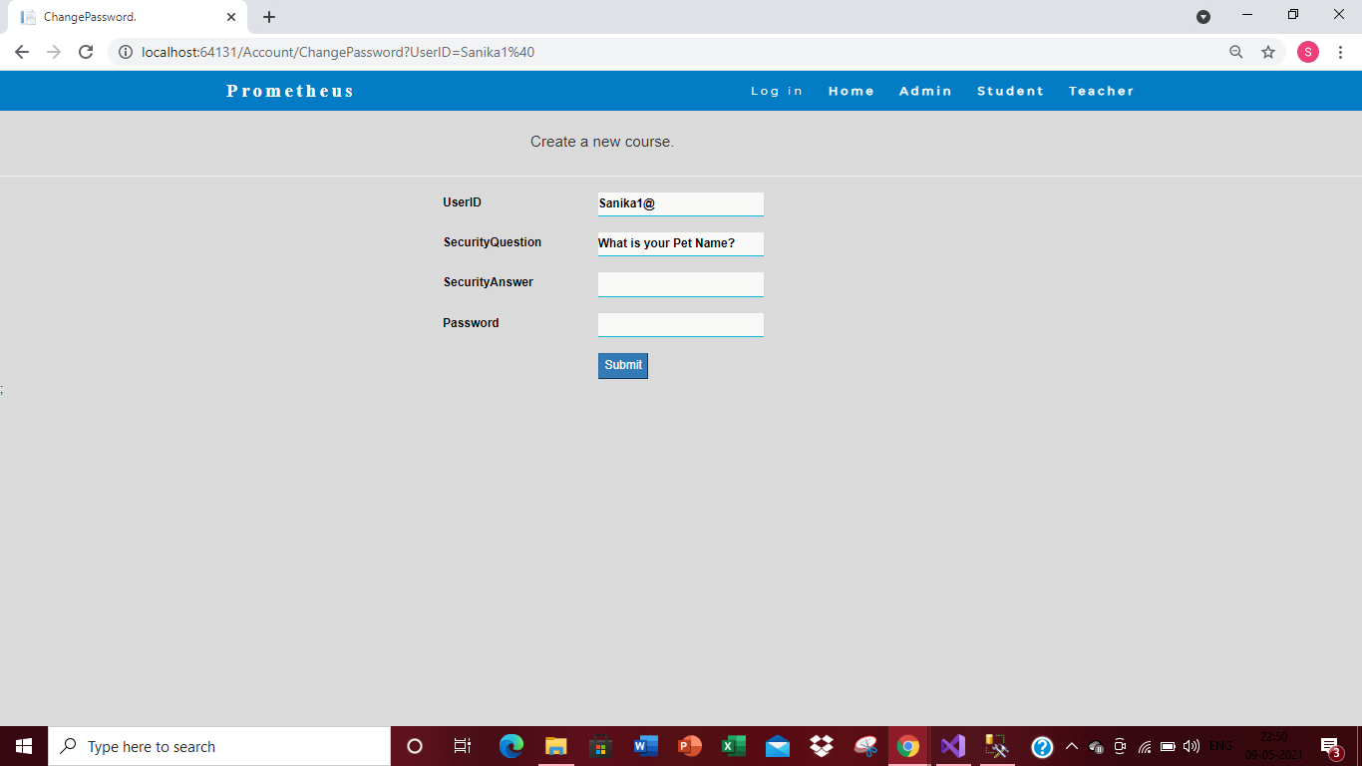

Fig.5.33: Incase, User forgot his password he can set-up a new password. He has to enter his username and needs to correctly answer to the security question which should match with the answer which he gave during registration process.

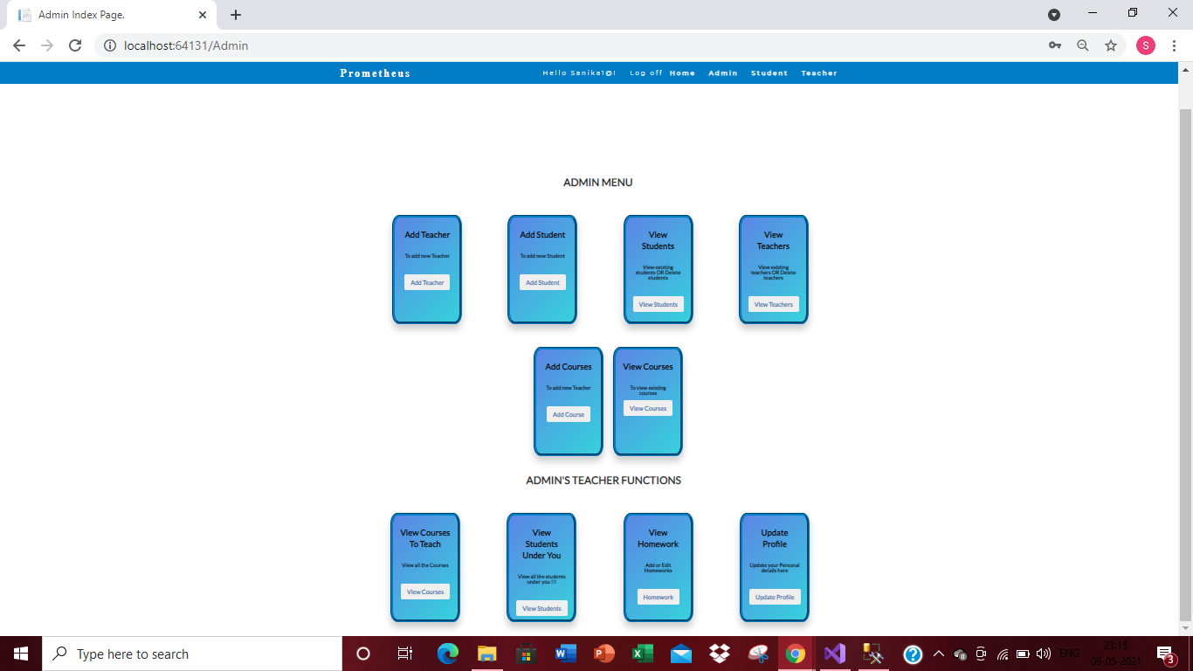

Fig.5.34: Admin Main Page

37

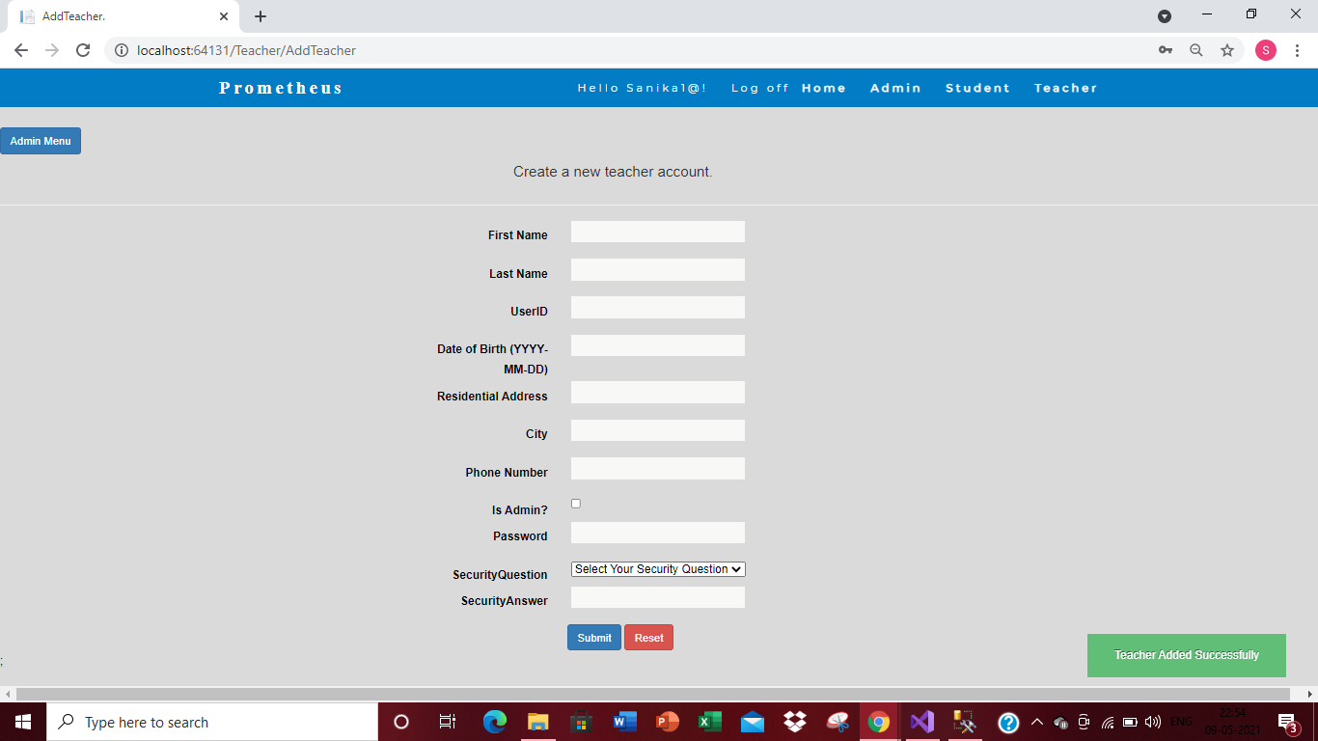

Fig.5.35: Admin Add Teacher Page

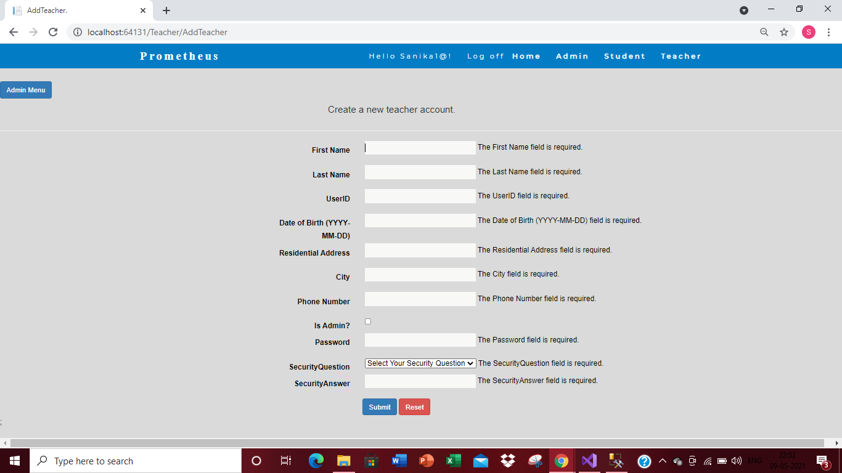

Fig.5.36: Validations applied on each input field of Teacher Registration.

38

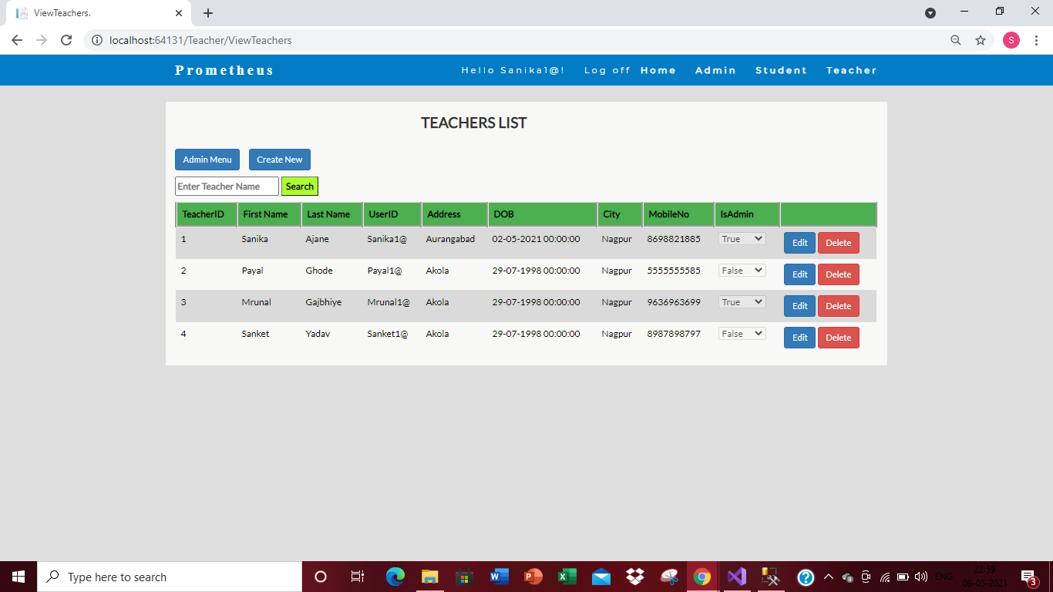

Fig.5.37: Admin can view list of all the teachers added into the application.

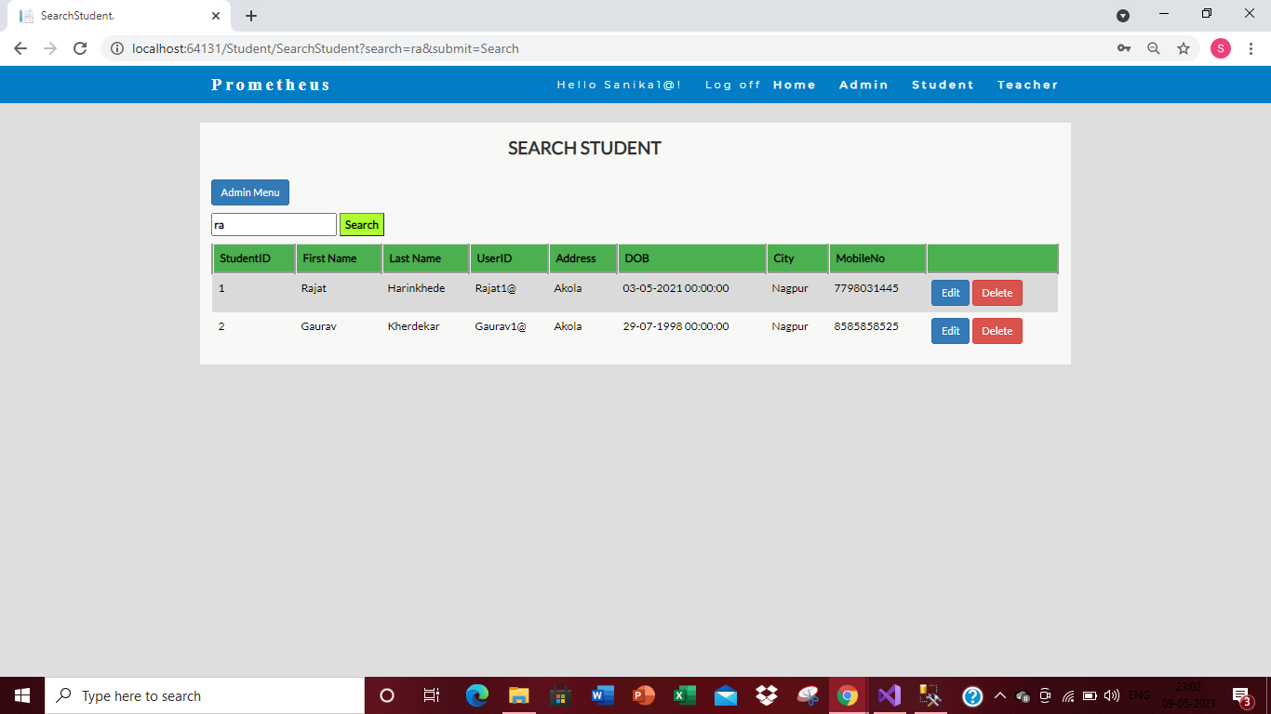

Fig.5.38: Admin can search students.

39

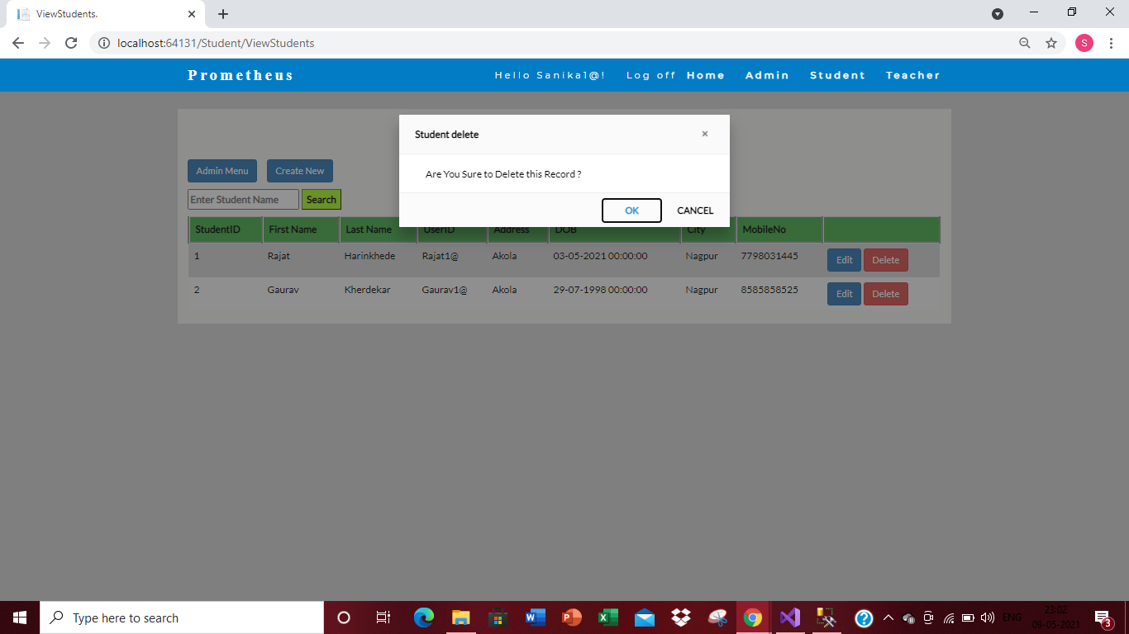 Fig.5.39: Admin can delete any record

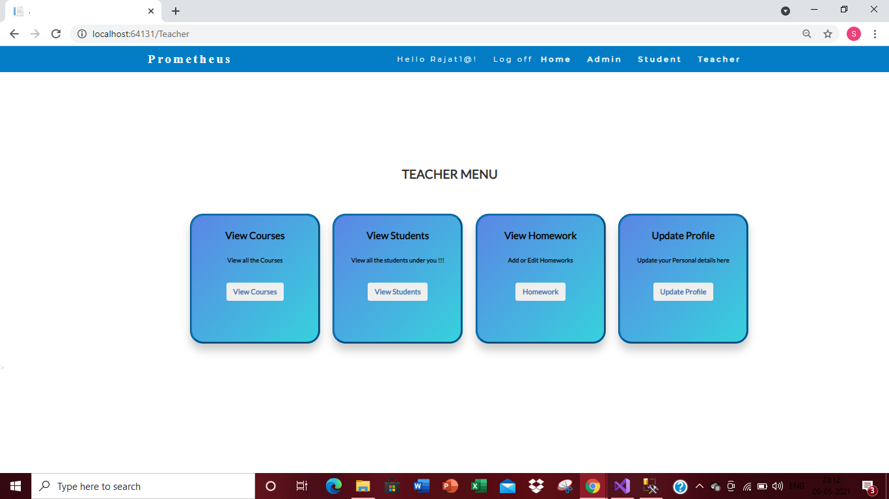

Fig.5.40 : Teacher Main Page

40

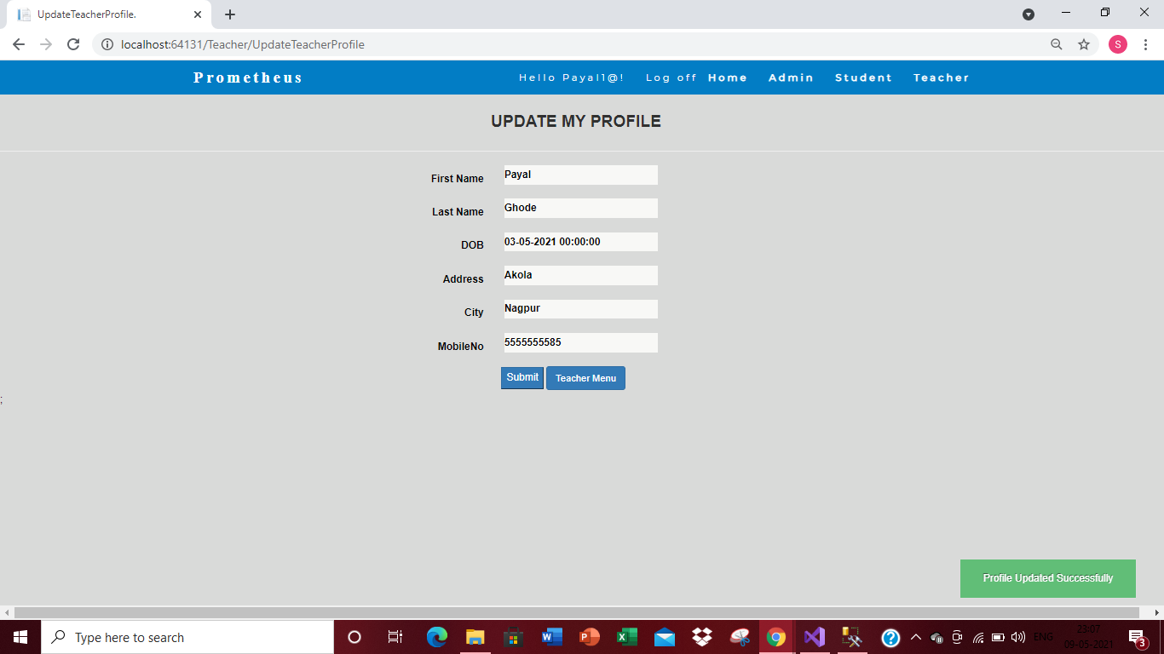

Fig.5.41 : Teacher Update Profile

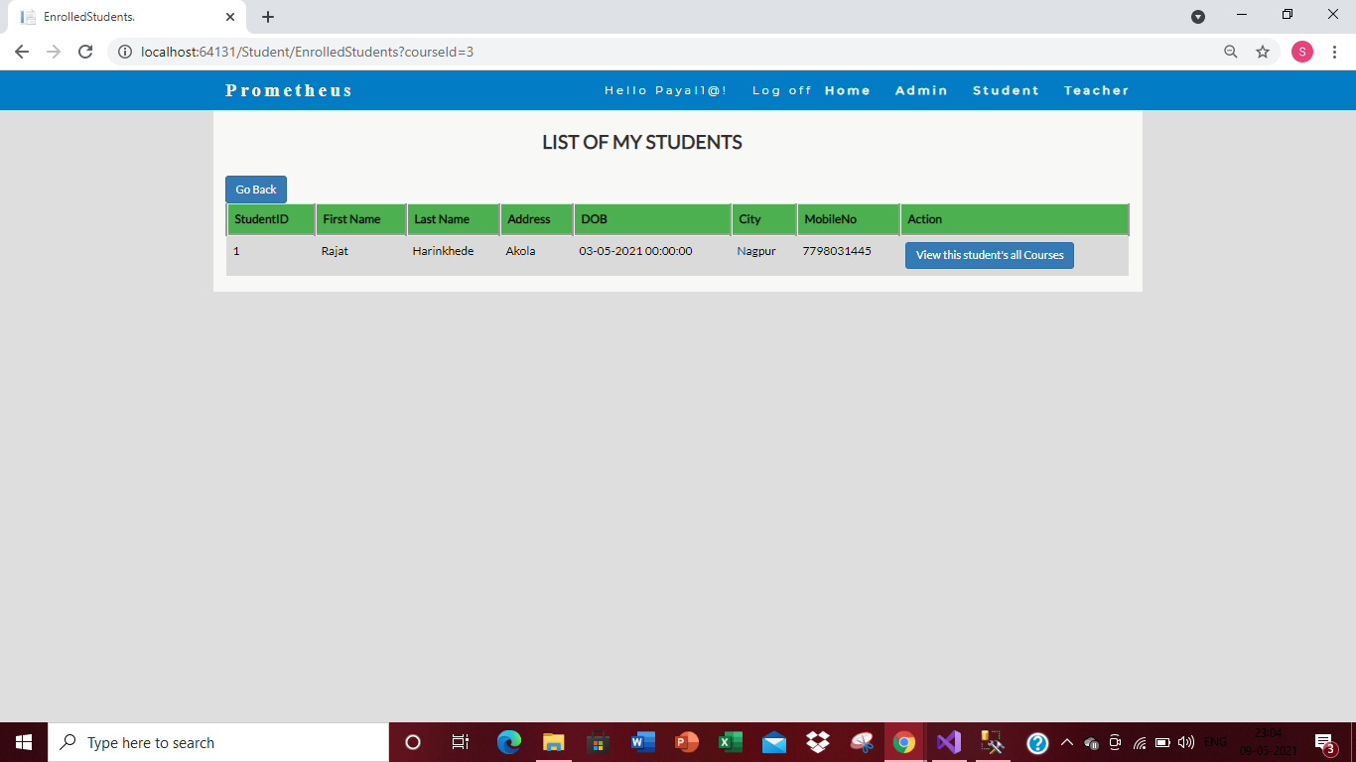

Fig.5.42 : Teacher can View Details of Students Enrolled in particular courses

41

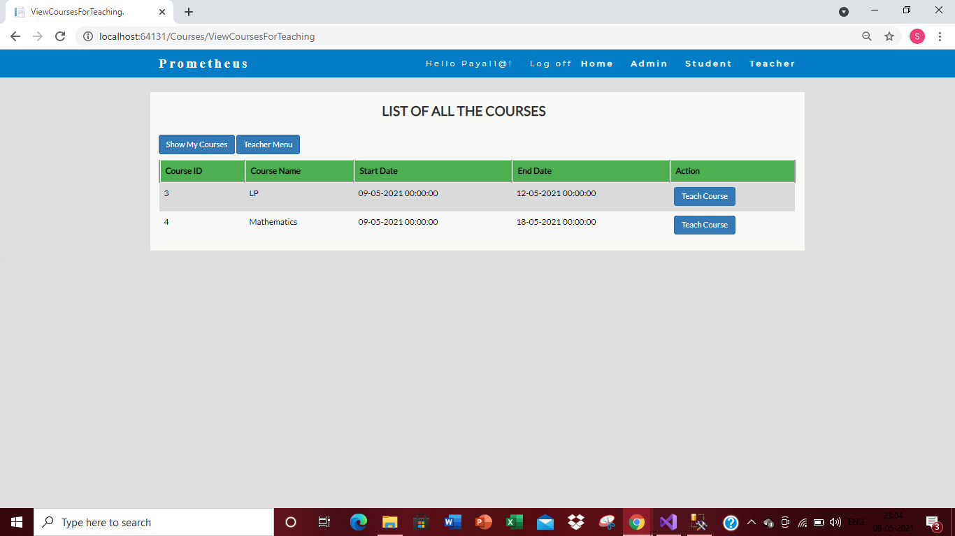

Fig.5.43 : teacher can View All Courses

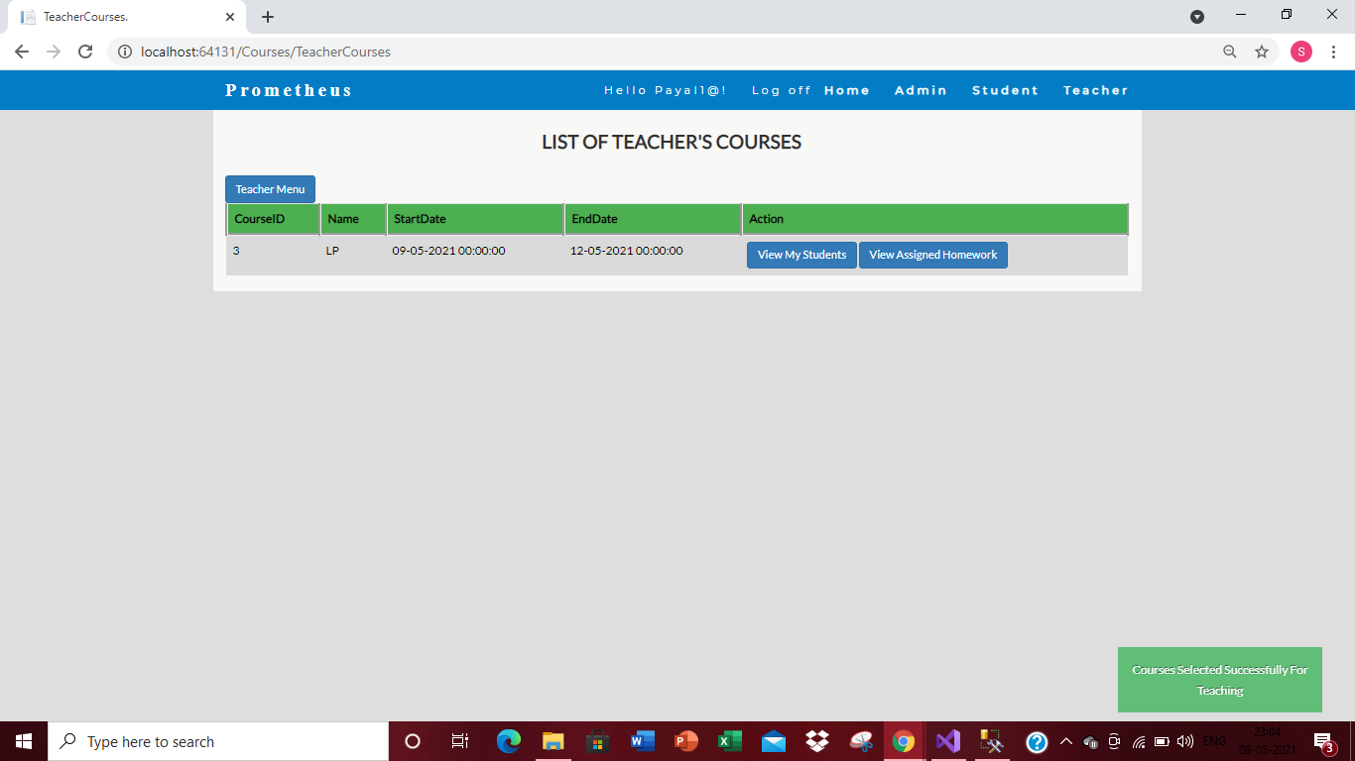

Fig.5.44 : Teacher can add course to teach

42

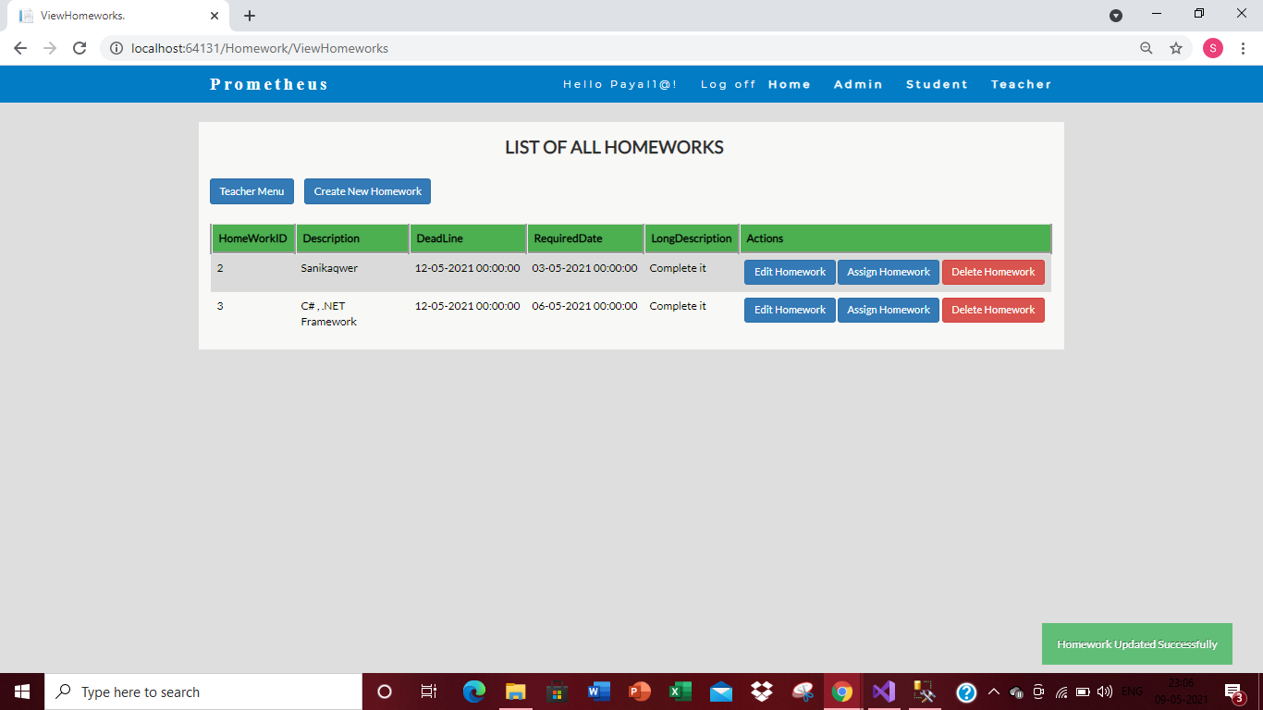

Fig.5.45 : View All Home-works and delete Homework on click of a button

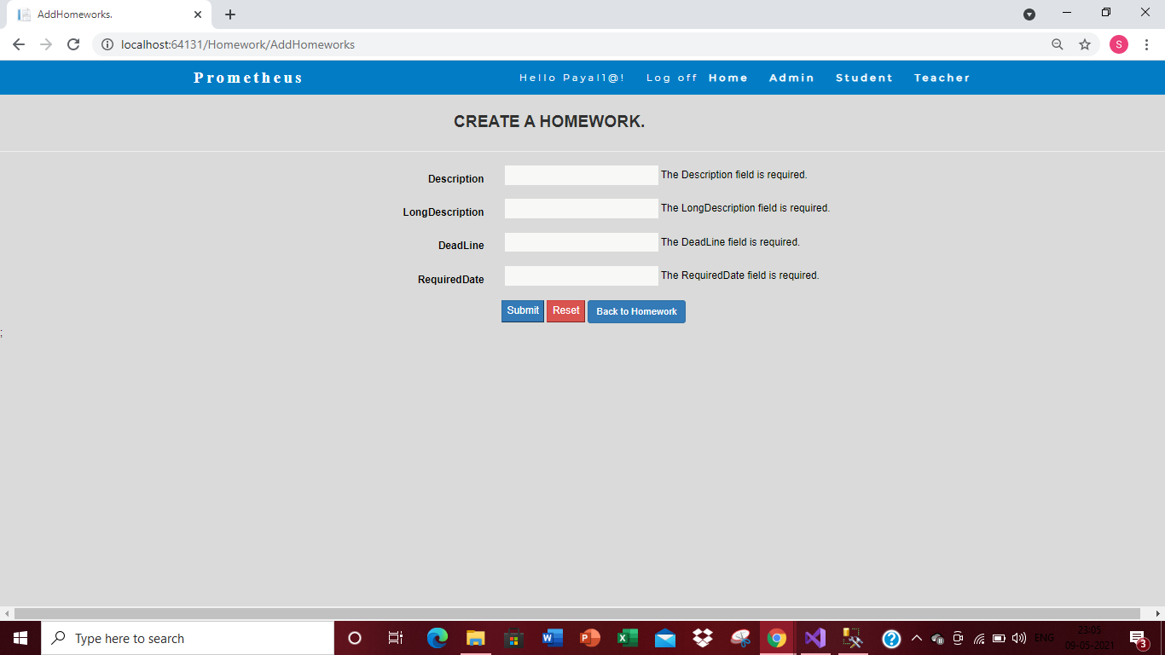

Fig.5.46 : Create New Homework with validations over it

43

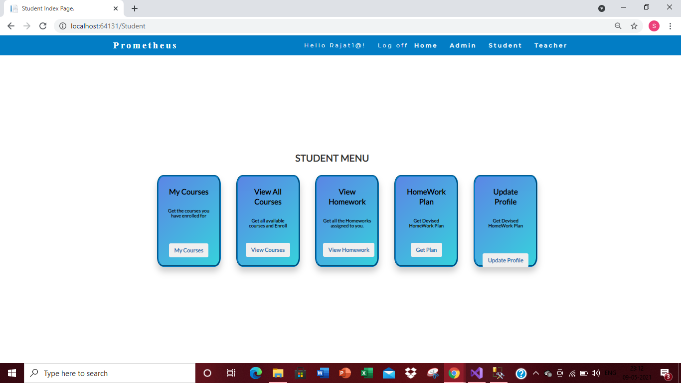

Fig. 5.47 Student Main Menu page

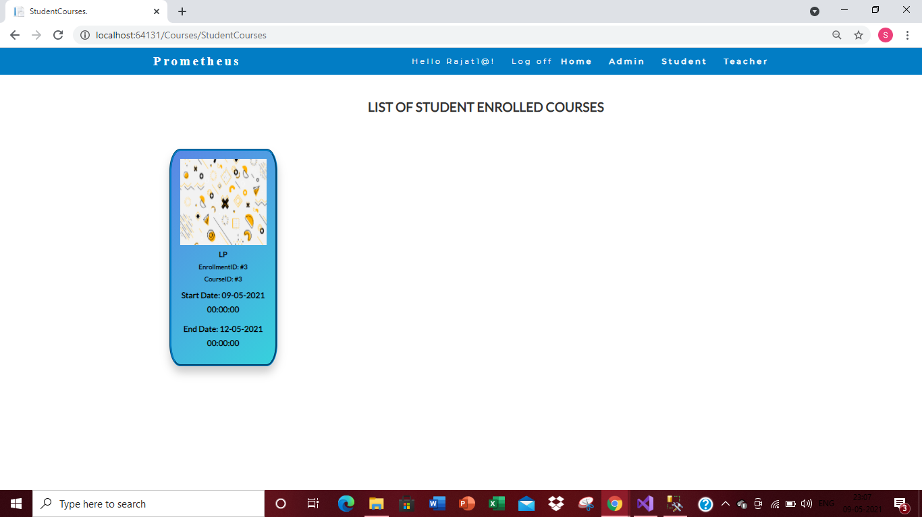

Fig. 5.48 Courses Enrolled by student display page.

44

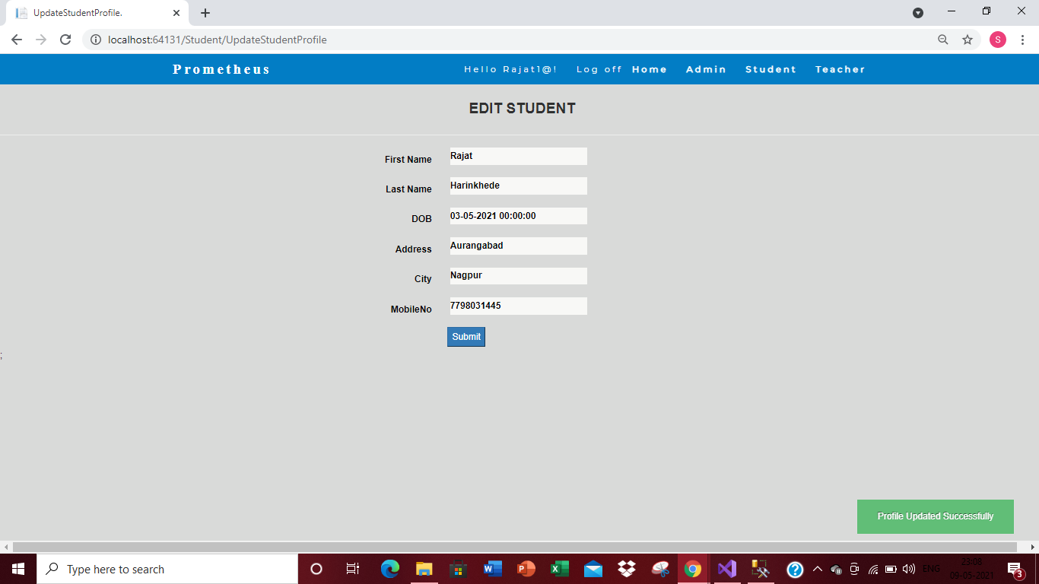

Fig. 5.49 Update student profile page.

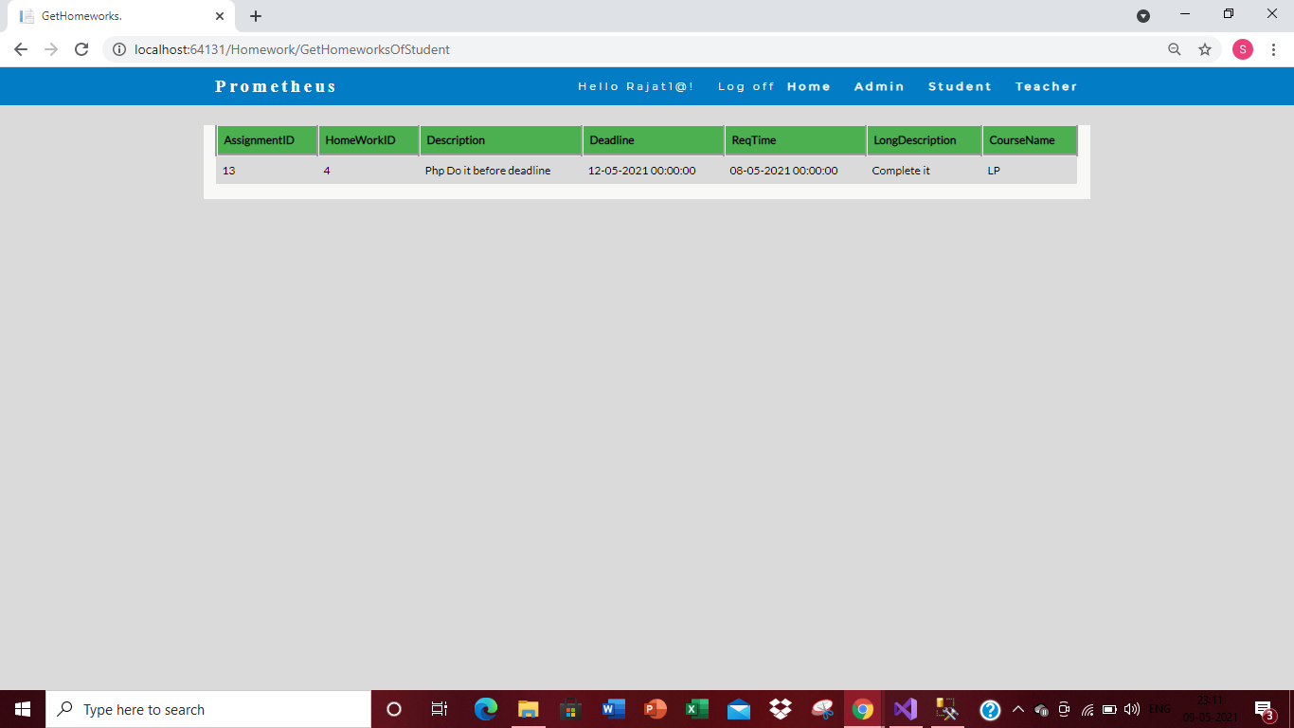

Fig. 5.50 Student View Homework Page.

45

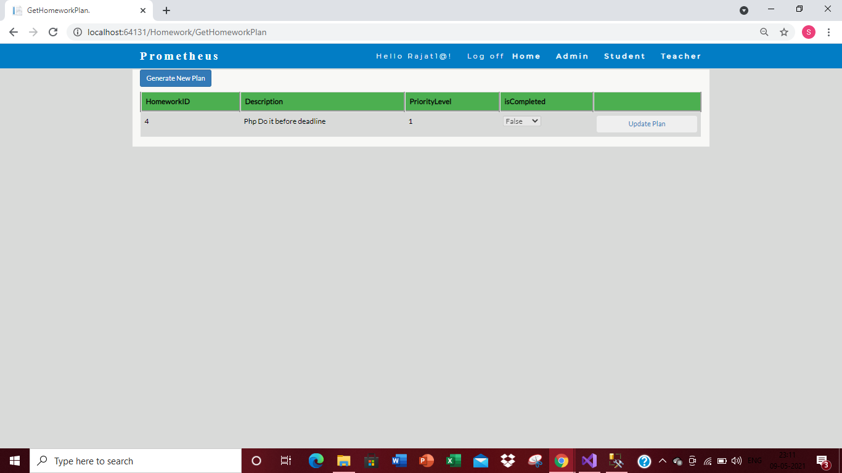

Fig 5.51 Student View Homework Plan page.

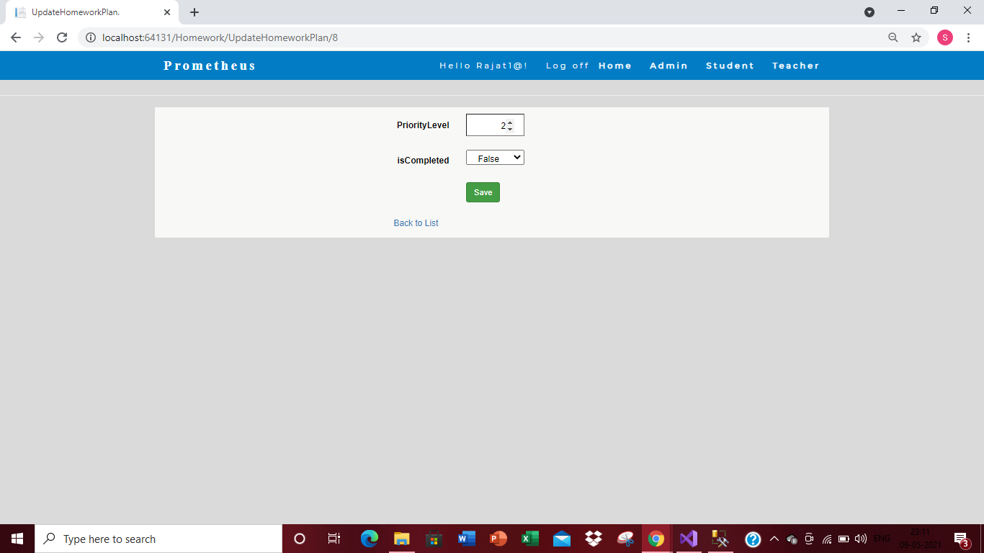

Fig 5.52 Update homework plan for student.

46

**Chapter 6**

**TESTING AND RESULTS**

**CHAPTER 6: TESTING AND RESULTS**

**6.1 Testing**

For overall running of the Project, we have to ensure that every Method/Functions are running properly. For that we have used Unit Testing in our project so that we can check each and every method or function of each and every directory are running properly or not. for Unit Testing we have created a separate directory where we created sub folders and named them according to the different directories. Then we created Unit Test Functions to check if the test outputs are successfully running or not.

After running each and every Unit Test Function we found out that all of the functions or methods that uses only table are running properly and after passing the values through Unit Test Functions, the main functions are executing successfully. The Unit Tests of async functions were also successfully running.

**6.2 Results**

The unit tests conducted by our team; the application runs with 92% of accuracy. Now, this application is ready to be deployed where a student has full privacy to make his homework plans which is hidden from teacher. Also, teachers now can relax as there is no need to maintain logs of homework that they want to assign to their respective students. This online homework planner indeed will make lives of both the parties more relaxing and fun in these days of pandemic where everything is on fingertips

According, to the case studies that we came across we suggest that this online homework planner will definitely help improve mental health of students which will reflect onto their marksheets. Also helping teachers to low down their stress improving their quality of lectures. So definitely the application will change the way students look at studies.

47

**Chapter 7**

**INDUSTRY CASE STUDIES UNDERTAKEN**

**CHAPTER 7: INDUSTRY CASE STUDIES UNDERTAKEN**

This application is made for students and teachers to help them make plan their homework on the basis of their priority. This application will be an extension to Blackboard which are in schools. This application is a stand-alone application and it extends Blackboard in a way that it provides a possibility that Blackboard does not offer. If this application proves to be successful, the two systems can be integrated to give best results. For the time being Prometheus is designed as a stand-alone system application.

The system should cater the following requirements:  
• teacher be able to see which students are enrolled in their courses.  
• teacher be able to add homework to the application, with proper deadline and an estimate of the time required to complete it.  
• teacher be able to add homework for their own teaching courses and be able to edit their posted homework. Its deadline cannot occur on the created date is the condition.  
• teacher can overview for each course that tells them which other courses their students have enrolled into.  
• students be able to enroll for the available courses given by admin and should not be able to enroll in a course that they have already enrolled in.  
• students be able to look for which courses they are enrolled into.  
• students have an overview of all the homework posted in one course and the required amount of time, the deadline and the content of the assignment can be read from this overview created.  
• students have an overview of all the homework posted that they are assigned to do so by their respected teachers.

Phase 1: Create simple basic structure for application using class object and relation using Class Library and WPF Application Project.   
Modules:

* Student Class: will allow to manage all of the student.
* Employee Class: will allow to manage all of the Employee.
* Course Class: will allow to manage all of the Course.
* Enrollment Class: will allow managing Enrollment.
* Homework Class: will allow managing Homework.

48

**Prototype should follow the functionalities given below:**  
i. Login / Sign in: Login screen should show asking user to enter ‘User Id’ & ‘Password’. If the given user credentials are valid the Home Page would be shown, else appropriate Login error message would be shown.

ii. Home Page: On successful user authentication and login (validation of user id/password provided by the user in login screen) the homepage would be shown. The main page would contain below sections/contents:

**Header section: The header section would be common across all the module pages and would mainly have –**  
• Sign in Link –click on it would take to Login page  
• Registration Link- click on it would take to Registration page  
• Search: Search for information for forgot password

**Main content section**: It would display Welcome message giving information of the site. Should have menu for Teacher, Student and Admin.

1. **For Student**  
   i. option to add, update the personal information  
   ii. Search  
    For available Courses.  
    For their Homework.  
   iii. to devise a planning for their Homework.
2. **For Teacher**  
   i. option to add, update the personal information  
   ii. View the details of all Courses  
   iii. View the details of all Students  
   iv. View all Homework assignments for their students.

49

**Create the following tables**:

i. Teacher: TeacherID, FName, LName Address, DOB, City, Password MobileNo, IsAdmin  
ii. Student: StudentID, FName, LName, Address, DOB, City, Password, MobileNo  
iii. Course: CourseID, CourseName, StartDate, EndDate  
iv. Teaches: TeacherID, CourseID  
v. Enrollment: CourseID, StudentID

vi. Homework: HomeWorkID, Description, Deadline, ReqTime, LongDescription  
vii. Assignment: HomeWorkID, TeacherID, CourseID

* **Sprint1 Technology:**  Develop Presentation components (WPF application), Business components (C# classes) and Data access components ([ADO.NET](http://ado.net/))

* **Sprint2 Technology:**  Develop Presentation components ([ASP.NET](http://asp.net/) MVC, Entity Framework, [ASP.NET](http://asp.net/) Web API)

50

**Chapter 8**

**CONCLUSION AND FUTURE WORK**

**CHAPTER 8: CONCLUSIONS AND FUTURE WORK**

**8.1 Conclusion**

The aim of the project was to develop a platform where Teacher can assign homework to their students through the application and Students can complete the homework according to the deadline or according to his/her priority. This project helps lessen the teacher’s burden to manually give homework to students. Also helps the students to make a homework plan according to their priority.

**8.2 Future Work**

1. There can be a notification service which can notify a student whenever a homework is being assigned to the subject the student is enrolled in.
2. The User Interface can further be improved for better user experience.
3. Regular Performance and security upgrades will be pushed.

51

**REFERENCES**

**REFERENCES:**

1. Yujun Li, Hao Zheng, Tengfei Yang, Zhiqiang Liu and Design and Implementation of a Library Management System Based on the Web Service. Computer Technology and Applications, 2012.

2. Xuebin Chen, Shufen Zhang, Shuai Zhang and Experiment teaching management system based on three-layer architecture. College of Science and 2013.

3. Qiao Li Chen, Yu Hu Feng and The design and application of the online bookstore system .Net based on three tier architecture. 2015.

4. Han Cuiping and Design and implementation of student management system of educational management system, China, 2014

52